Azure Databricks

# Reference:

Useful Links

Azure Portal – [https://portal.azure.com](https://portal.azure.com/)

Ergast API Documentation - <http://ergast.com/mrd/>

PySpark Documentation - <https://spark.apache.org/docs/latest/api/python/index.html>

PySpark API Reference - <https://spark.apache.org/docs/latest/api/python/reference/index.html>

Spark SQL Reference - <https://spark.apache.org/docs/latest/sql-ref.html>

# Apache Spark overview

Apache Spark is a lightning-fast unified analytics engine for big data processing and machine learning.

## Characteristics:

100% open source under Apache License

Simple and easy to use APIs

In-memory processing engine

Distributed computing platform

Unified engine which supports SQL, streaming, ML and graph processing.

# Apache Spark architecture

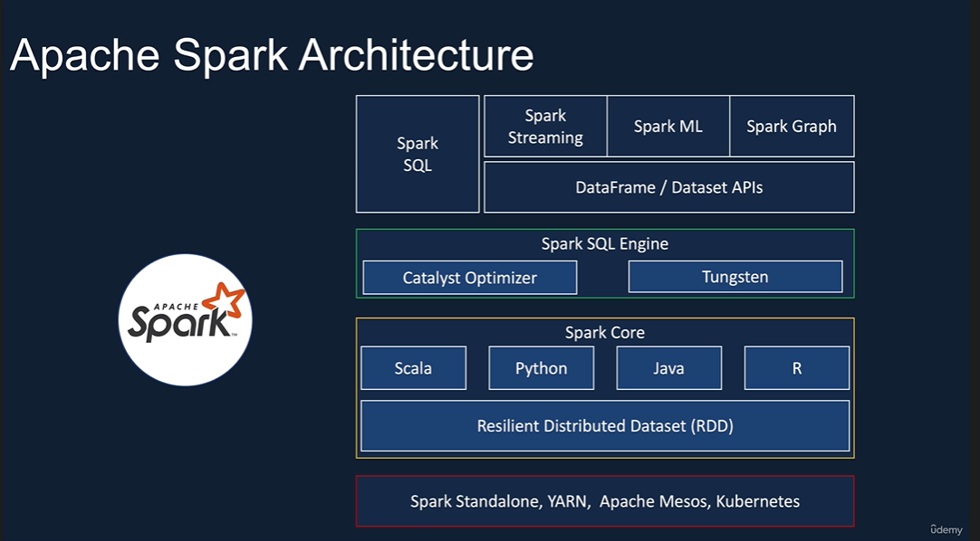

## Spark Core

Spark Core takes care of scheduling tasks, memory management, fault recovery, communication with storage systems etc. Its also home to Sparks’ main programming abstraction API called RDD or Resilient Distributed Datasets. RDDs are collection of items distributed across various compute nodes in the cluster that can be processed in parallel. Spark Core provides the APIs to create and manipulate these RDD collection. Early development in Spark was done using these APIs but it had its drawbacks. It was difficult to use for complex operations and for optimizing sparks and mainly dependent on the developer to write the optimized code.

## Spark SQL engine

To optimize the workload, Spark introduced the SQL engine. It includes the Catalyst optimizer which takes care of converting a computational query to highly efficient execution plan and a Tungsten project which is responsible for memory management and CPU efficiency.

The high-level abstraction such as Spark SQL, Datasets and Dataframes APIs make it easier to develop applications and benefit from the optimizations from SQL engine. The recommended approach is to use these high level APIs rather than RDD APIs. The data set and data frame APIs can be invoked from any of the domain specific languages such as Scala, Python, Java or R. On top of these, we have a set of a libraries such Spark Structured Streaming, MLlib for Machine Learning and GraphX. Also Spark comes with its Standalone resource manager but you can choose other Resource managers such as YARN, Apache Mesos and Kubernetes.

Combining all of these, Spark provides a unified platform for streaming, batch, machine learning and graph processing workloads using a single execution engine on a standard set of APIs.

But to work with Spark, we have to setup our own clusters, manage security and also use third party products to write our programs. That’s where Databricks comes in.

# Databricks

Databricks is a company founded by creators of Apache Spark to make it easier to work with Spark on cloud.

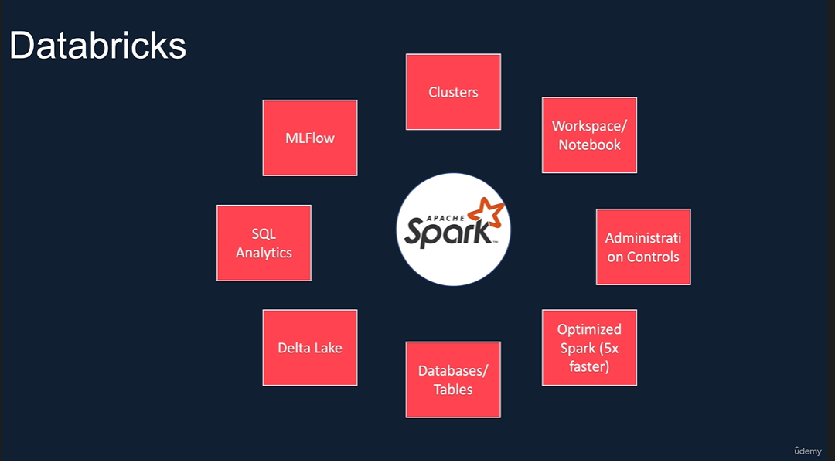

## Clusters

For Spark to do its distributed computing, you need to spin up clusters and install software. Databricks gives you the ability to spin the clusters with a few clicks. You can choose the runtime which is suitable for your needs. E.g. You can choose a runtime with ML libraries, support for GPU etc. Also you can choose from a wide range of clusters ranging from general purpose, memory optimized, compute optimized or GPU enabled.

## Workspace/Notebook

It provides a Jupyter notebook-styled IDE with additional capabilities to create your applications, collaborate with your colleagues and also integrate with configuration management tool such as Git.

## Administration Controls

It provides Administration Controls to restrict or provides access to users to workspaces, clusters etc.

## Optimized Spark

On top of this, Databricks provides the Spark runtime which is highly optimized for the database platform and is known to be 5x faster than vanilla Apache Spark.

## Databases/Tables

With the use of Hive metastores, Databricks provides ability to create databases and tables.

## ACID transactions with Delta Lake

To provide ACID transaction properties, Databricks comes with open-source project called Delta Lake.

## SQL Analytics

A recent addition to Databricks is SQL analytics which provides a data analyst a SQL based analytics environment to explore data, create dashboards, schedule a regular refresh of dashboards.

## Managed ML flow

It comes with Managed ML flow which allows to manage ML lifecycle including experimentation, deployment, model registry etc.

# Azure Databricks

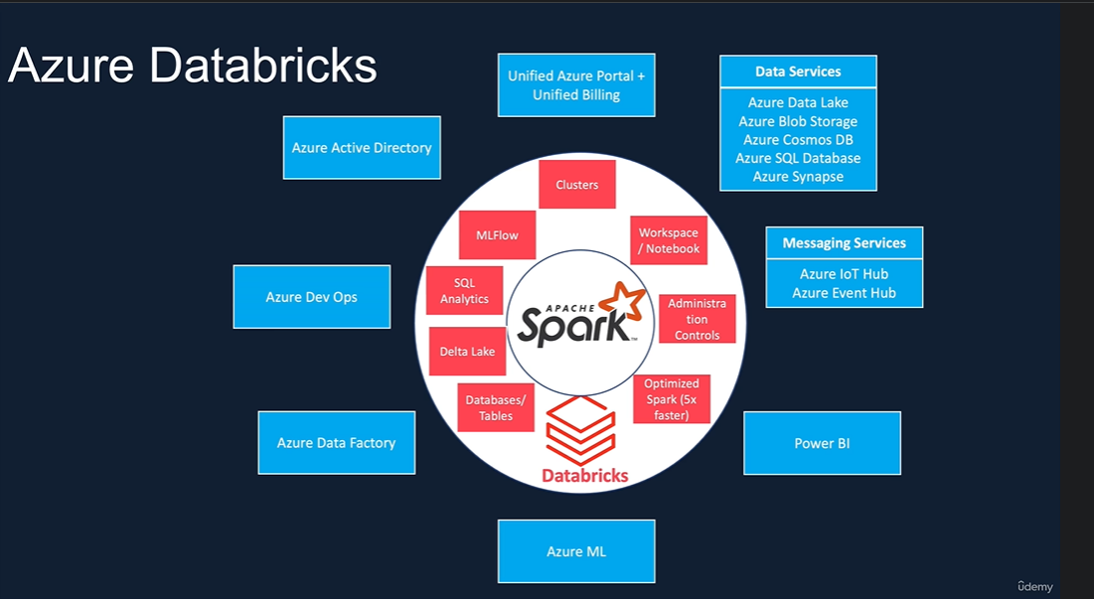

With recent announcement from Google in Feb’21, Databricks is available on all three major cloud platforms: AWS, Azure and GCP. But Azure’s integration is deeper than others. Databricks is a first party service on Azure which means you will be buying Databricks directly from Microsoft and all support requests will be handled by Microsoft.

As a result, it provides a unified portal and billing for all Azure services including Databricks.

Azure Databricks (ADB) leverages Azure security with seamlessly integrates with Azure Active Directory (ADD) and Single-Sign On (SSO).

It provides seamless integration and high-speed connectors with various Azure data services such as Azure Data Lake, Azure Blob storage, Azure Cosmos DB, Azure SQL database, Azure Synapse.

Messaging services such as Azure IoT Hub and Event Hub.

Power BI.

Azure ML.

You can seamlessly run Databricks from Azure Data Factory and integration with data workflows in your project.

And finally, Databricks connects with DevOps for CI/CD.

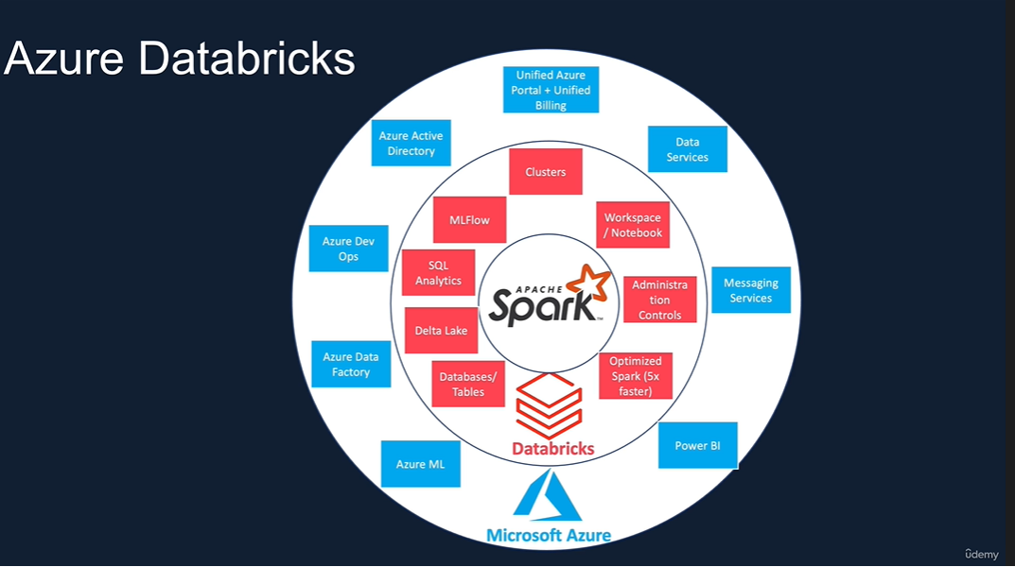

Clusters types:

All-purpose

Jobs

Jobs clusters are option for you to schedule your notebooks to run at regular intervals.

In Models, you can see models for your ML Jobs.

You can create access tokens so you can connect Power BI with ADB clusters.

# Azure Databricks Architecture

It’s split into two parts: Control plane and Data plane.

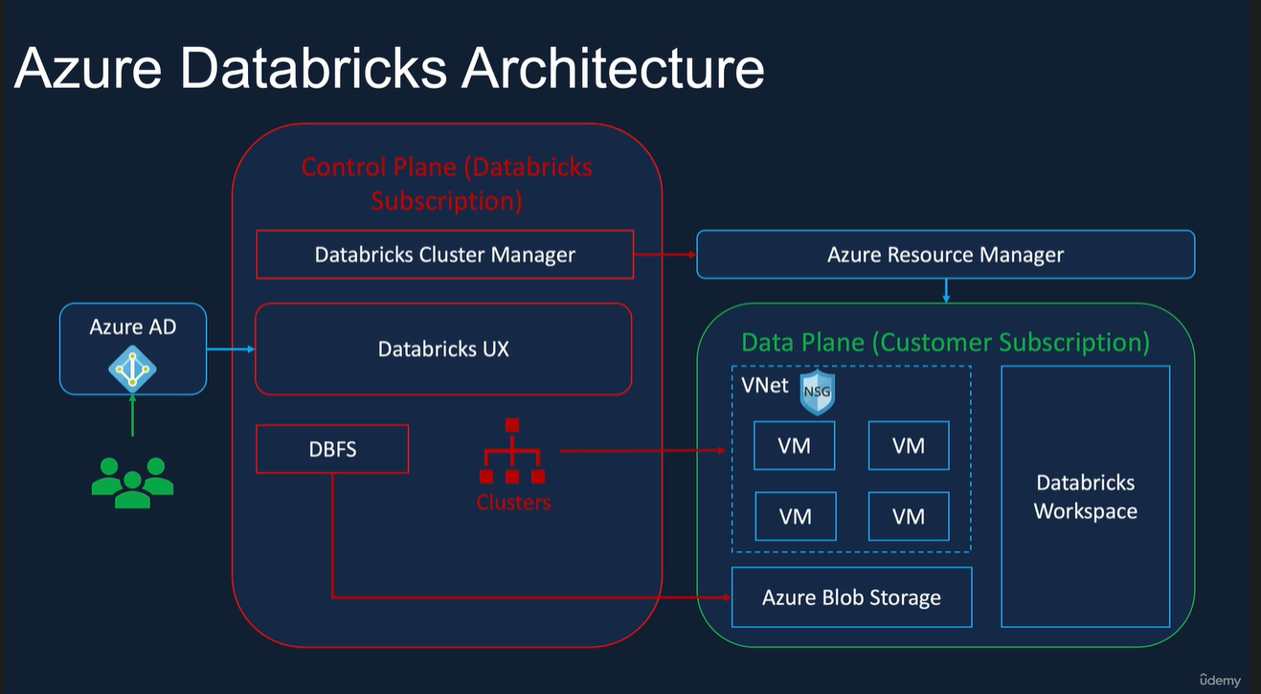

## Control plane

It is in Databricks owned subscription. It contains Databricks UX, cluster manager, Databricks File System (DBFS) and metadata about clusters, files mounted.

## Data plane

It is in the customer subscription. When you create a Databricks service in Azure, there are 4 resources created in your subscription. A virtual network (VNet), Network Security Group (NSG) for the VNet, Azure Blob storage for the default storage and a Databricks workspace.

The databricks users such as Data engineers, Data scientists and Data analysts will use Active Directory single sign-on to access a databricks service.

When a user requests for a cluster, the databricks cluster manager will create the required virtual machines in our subscription via Azure resource manager. So none of the customer data leaves the subscription. Temporary outputs such as running a display command or data from managed table are stored in the Azure blob storage. The processing happens within the VNet within our subscription.

The Azure Blob storage is the default storage or otherwise called a DBFS root. It’s not recommended for permanent data storage. For that we can mount other storage accounts.

# Databricks Clusters

A cluster is a collection of virtual machines. In a cluster, there is usually a driver node which orchestrates the tasks performed by one or more worker nodes. Clusters allow us to treat these group of computers as a single computer via the driver node. Databricks clusters allow us to run different types of workloads such as ETL for data engineering, data science and Machine Learning workloads.

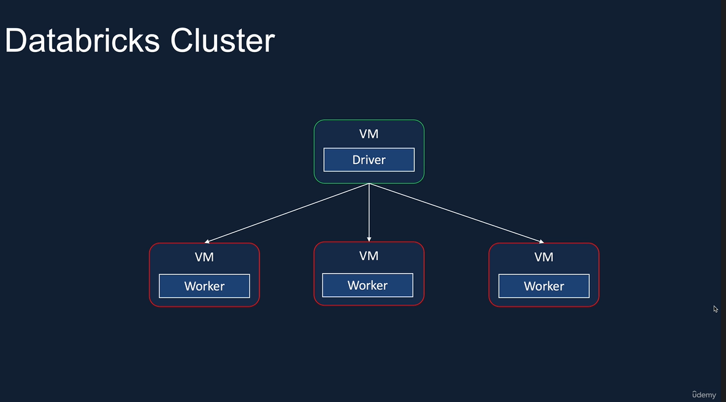

## Cluster Types:

Databricks offers two types of clusters.

The first one is an All-purpose cluster which is created manually via the GUI, CLI or the API. The other one is a Job cluster that’s created when a job starts to execute and the job has been configured to use a Job cluster rather than an All-purpose cluster.

All-purpose clusters are persistent; they can be terminated and restarted anytime. On the other hand, the job clusters are terminated at the end of the job. They cannot be restarted hence they no longer are usable once the job has completed.

All-purpose clusters are suitable for interactive workloads and ad-hoc analysis workloads. Job clusters are suitable for automated workloads such as running an ETL pipeline or ML workloads at regular intervals.

All-purpose clusters can be shared among many users, and they are good for collaborative analysis. On the other hand, job clusters are isolated just for the job being executed.

All-purpose clusters are expensive to run compared to Job clusters.

## Cluster Configuration

Once we have decided on cluster type, we need to look at configuration of the cluster.

One of them is Cluster Modes.

### Cluster Modes

Databricks offers three different modes namely Standard, High Concurrency and Single Node.

1. Standard
2. High Concurrency
3. Single Node

Standard and Single-node clusters are meant for single users and High Concurrency clusters are meant for multiple users.

Because Standard and Single-node clusters don’t offer any process isolation so failure in one user’s process may affect other users.

Also, they don’t offer any Task Preemption so one running process may use all the resources and others will fail whereas the High Concurrency clusters offers both Process Isolation and Task Preemption to enforce fair sharing of resources.

Both Standard and Single Node clusters support all Domain Specific Languages such as Scala, Python and R whereas High Concurrency clusters don’t support Scala.

In terms of use cases, Standard clusters are good for production workloads and ad-hoc development work. High Concurrency clusters are good for interactive analysis which is usually done by more than one analyst, and ad-hoc development work. The administration overhead is low as we don’t have to create separate clusters for each of the users. Single Node clusters are good for lightweight ML and data analysis workloads which don’t require distribute processing.

### Databricks Runtime

Databricks Runtimes are set of core libraries that run on Databricks Clusters. Databricks offers 4 types of runtimes.

1. Databricks Runtime
2. Databricks Runtime ML
3. Databricks Runtime Genomics
4. Databricks Runtime Light

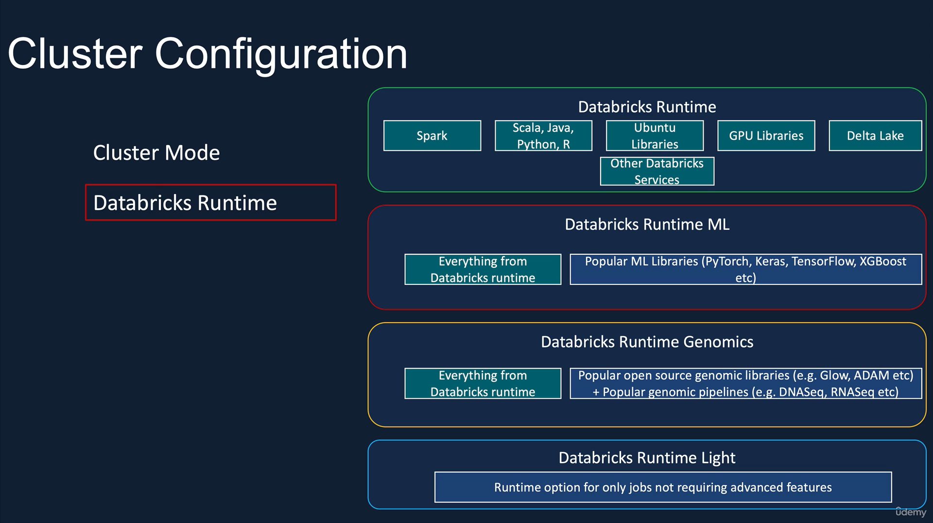

#### Databricks Runtime

Databricks Runtime includes an optimized version of Apache Spark libraries, Java, Python, Scala, and R libraries, GPU libraries for GPU enabled clusters, Delta Lake and next generation storage layer built on top of Apache Spark that provide ACID transactions, optimized layouts and indexes, other Databricks services that integrate with other component of Databricks such as Notebooks, Jobs and Cluster Managers.

#### Databricks Runtime ML

It includes all the libraries from Databricks Runtime and popular ML libraries such as PyTorch, Keras, TensorFlow, XGBoost etc.

#### Databricks Runtime Genomics

It includes all the libraries from Databricks Runtime and popular genomics libraries such as Glow, Adam etc. and popular genomic pipelines such as DNASeq, RNASeq etc.

#### Databricks Runtime Light

It’s for jobs that don’t require advanced features such as auto-scaling, reliability, improved performance etc. Also, it’s meant for automated workloads, you can’t use it for interactive workloads or notebook jobs.

### Auto termination

It’s a nice feature to avoid unnecessary cost on idle clusters. It’s especially useful on ad-hoc clusters for preventing them from running during evening or weekends when there are not in use. You can specify the idle timeout after which the cluster should be terminated if it’s not in use. Default timeout for Standard and Single Node clusters is 120 minutes. High Concurrency clusters don’t have a default value, but you can specify a value between 10 and 10000 minutes.

### Auto scaling

You can specify minimum and maximum number of worker nodes and Databricks will automatically scale up or down the worker nodes depending on the workload. This can result in optimum utilization of the cluster. This is especially useful when you are unsure about workload upfront or your workload changes throughout the process. They are not recommended for streaming workloads; even if you specify them, Databricks will default to maximum number of worker nodes.

### Cluster VM Types/Sizes

There is a wide array of Azure VM types available for use. Databricks groups them into a small number of easy-to-understand groups.

1. Memory Optimized
2. Compute Optimized
3. Storage Optimized
4. General Purpose
5. GPU Accelerated

#### Memory Optimized

The memory optimized instance types are suitable for memory intense applications such as ML workload that caches a lot of data in memory.

#### Compute Optimized

Compute optimized instance types are good for structured streaming applications where you need to make sure that the processing rate is about the same as input rate at peak hours of the day. This can also be used for distributed analytics and data science applications.

#### Storage Optimized

Storage Optimized are recommended for use cases requiring high disk throughput and I/O.

#### General Purpose

General Purpose are recommended for enterprise grade applications and analytics with in-memory caching.

#### GEP Accelerated

Finally, GEP Accelerated types are recommended for deep learning models that are data and compute intensive.

# Accessing Azure Data Lake from Databricks

Security access.

Data Lake provides three methods to access its services.

1. Storage Access Keys
2. Shared Access Signature (SAS) tokens. SAS tokens provide granularity.
3. Service Principal. We can create a service principal with access to a particular data lake and use those credentials in Databricks.

These three can be used in two forms.

1. Session scoped authentication.

The access will be valid for the duration of the notebook run.

1. Cluster scoped authentication.

The access will be valid as long as the cluster is live.

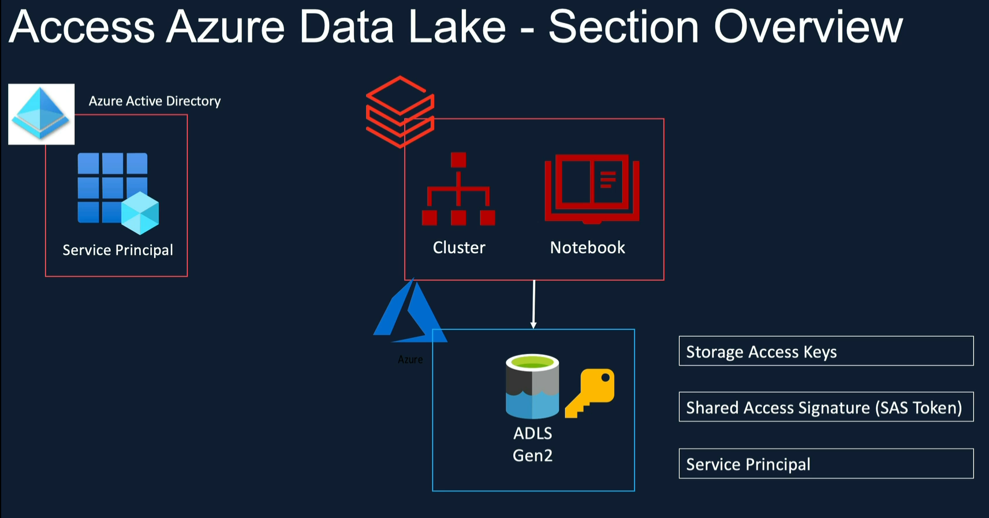

Apart from these, there are two more forms of authentication available in Azure Databricks.

1. Azure Active Directory (AAD) passthrough authentication.

If the user has access to the data lake and they run a notebook or a job, Databricks uses this user’s AAD credentials and use the access permissions assigned via Access Control IAM to access the data lake. It’s only available for premium workspace.

1. Unity Catalog.

This is a new addition. In this, the administrators can define permissions for a user. When user runs a notebook, the cluster will check for user’s access in Unity Catalog. This is also available only in Premium workspace.

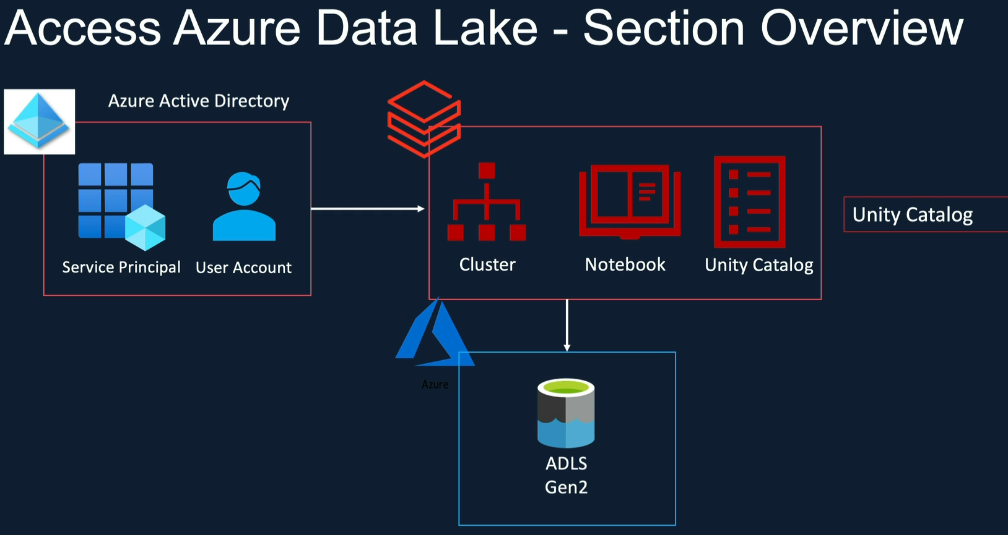

## Access Azure Data Lake Gen2 from Databricks using Access keys

When you create a storage account, Azure generates two 512-bit storage account access keys. They give full access. Consider this as super user. Azure recommends using Key Vault to secure them. In case the keys are compromised, you can rotate (regenerate) new keys.

In order for Databricks to access Data Lake, we can use one of the keys in a notebook.

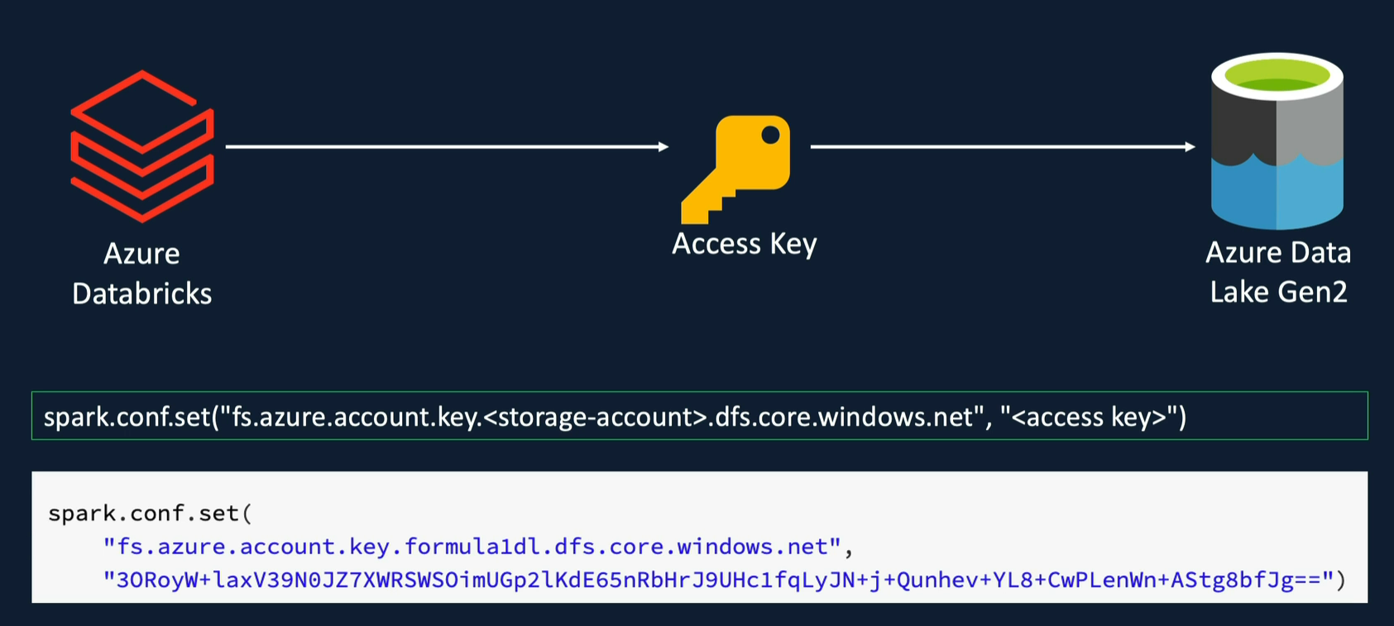

We can do this by assigning the access key to a Spark configuration called “fs.azure.account.key”.

The parameter is a combination of fs configuration and the endpoint of the storage account.

### ADFS driver

Let’s see how to access blobs from Datalake.

Microsoft recommends Azure Blob File System (ADFS) driver. It’s a new driver that is part of Apache Hadoop suite of products and it’s optimized for big data analytics and offers better security.

Refer: <https://learn.microsoft.com/en-us/azure/storage/blobs/data-lake-storage-abfs-driver>

The URI of a blob follows this convention:

“abfs[s]://<container_name>/<storage_account_name>.dfs.core.windows.net/folder_path…/file_name

An example would look like this:

1. “abfss://demo@formula1dl.dfs.core.windows.net”
2. “abfss://demo@formula1dl.dfs.core.windows.net/demo/”
3. “abfss://demo@formula1dl.dfs.core.windows.net/demo/circuits.csv”

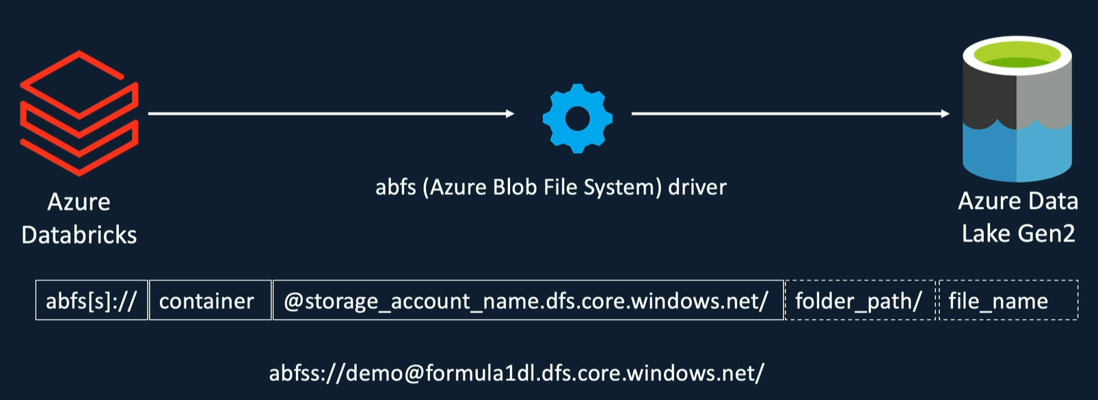

### Hands-on – List files at a storage account in ADLS.

Create a new notebook file called “access_adls_using_access_keys”

#### Error scenario #1

Write the command without passing the access keys:

dbutils.fs.ls(“abfss://demo@formula1dl.dfs.core.windows.net”)

When we execute this command, we get an error:

Failure to initialize configuration for storage account formula1dl.dfs.core.windows.net: Invalid configuration value detected for fs.azure.account.keyInvalid configuration value detected for fs.azure.account.key

Now we know if we encounter this type of error then we must have not passed the access keys.

To fix this error, we need to set the Spark configuration command before this fs.ls command using this example:

spark.conf.set("fs.azure.account.key.formula1dl.dfs.core.windows.net",

               "<storage-account-access-key>");

#### Error scenario #2

I mistakenly put incorrect storage account name and I encountered this error:

Operation failed: "Server failed to authenticate the request. Make sure the value of Authorization header is formed correctly including the signature.", 403, GET, <https://formula1dl.dfs.core.windows.net/demo?upn=false&resource=filesystem&maxResults=5000&timeout=90&recursive=false>, AuthenticationFailed, "Server failed to authenticate the request. Make sure the value of Authorization header is formed correctly including the signature. RequestId:acf0b439-201f-0035-6206-ecb709000000 Time:2024-08-11T15:50:23.2214129Z"

After successfully running the correct command, we can output. In my case, I had only one file in the storage account.

Output #1

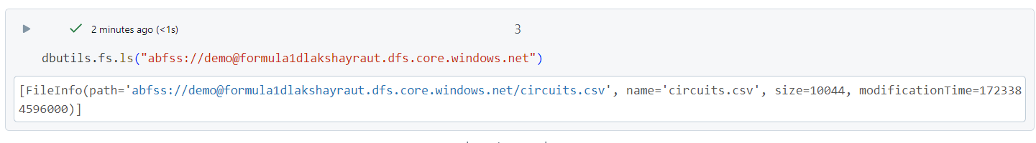

If you need a more readable output then wrap the command in display() function.

display(dbutils.fs.ls("abfss://demo@formula1dlakshayraut.dfs.core.windows.net"))

Output #2

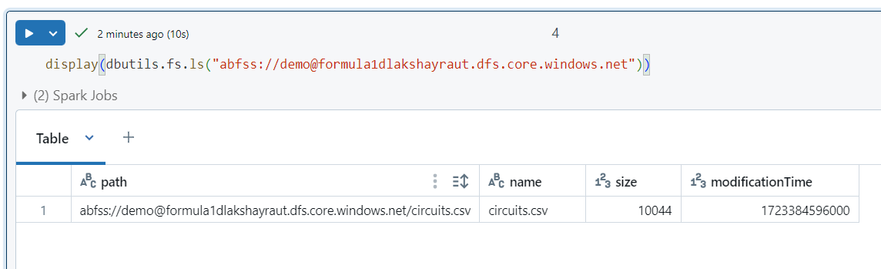

### Hands-on – Display contents of a file in storage account in ADLS.

We can use Spark Data Frame APIs.

Command:

spark.read.csv("abfss://demo@formula1dlakshayraut.dfs.core.windows.net/circuits.csv")

This command create a DataFrame object.

Output #1

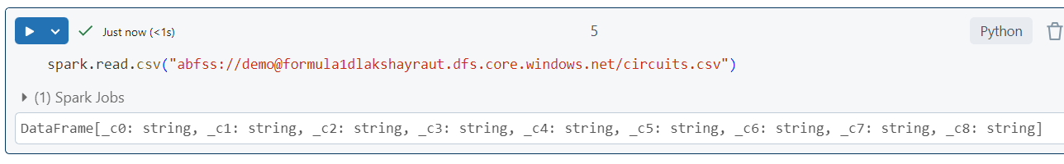

We can call display() on that data frame to display the contents.

Output #2

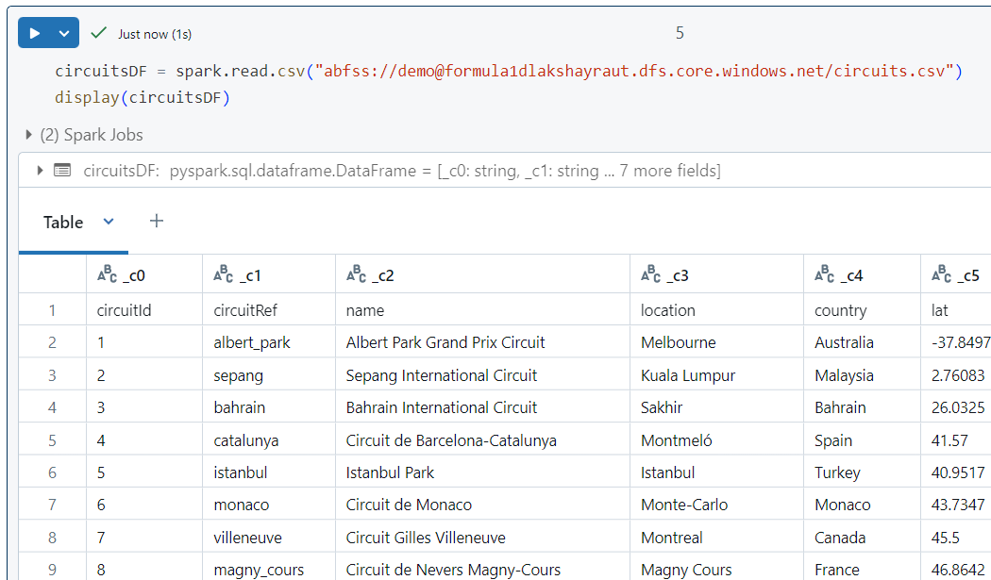

We have successfully used access keys to connect to ADLS and read contents of a file.

## Access Azure Data Lake Gen2 from Databricks using SAS tokens

1. Unlike access keys, SAS tokens can be used to control access at more granular level.
2. We can restrict access to a specific resource types/services. E.g. We can allow access to blob container but not queues, tables etc.
3. We can allow specific permissions such as read-only.
4. We can even allow time bound access.
5. Limit the access to a specific IP address.
6. This access method is recommended for external clients.

### To setup the SAS configuration, we need to run three spark configuration commands.

First – set the type of account authentication as SAS.

Command:  
spark.conf.set(“fs.azure.account.auth.type.<storage-account>.dfs.core.windows.net”, “SAS”)

Second – defines the SAS token provider.

Command:  
spark.conf.set(“fs.azure.sas.token.provider.type.<storage-account>.dfs.core.windows.net”, “org.apache.hadoop.fs.azurebfs.sas.FixedSASTokenProvider”)

Third – pass the SAS token.

Command:  
spark.conf.set(“fs.azure.sas.fixed.token.<storage-account>.dfs.core.windows.net”, “<sas-token>”)

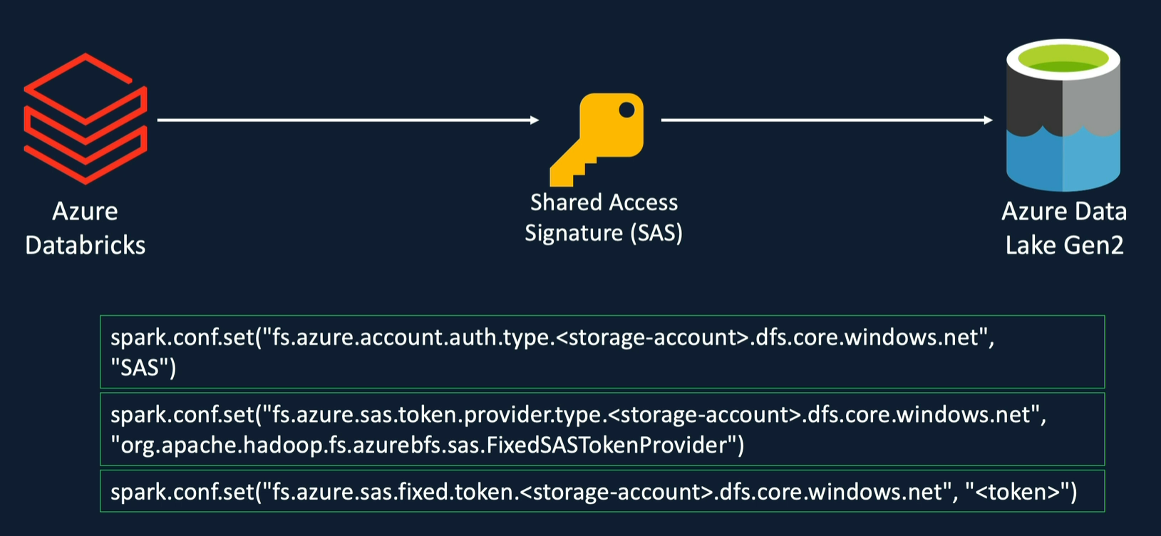

### Hands-on – Generate SAS tokens.

#### Method #1 – using Shared Access Signature menu.

Go to your storage account -> “Shared Access Signature” option in left nav menu and generate a new SAS token.

You can control the permissions on that screen.

Screenshot #1

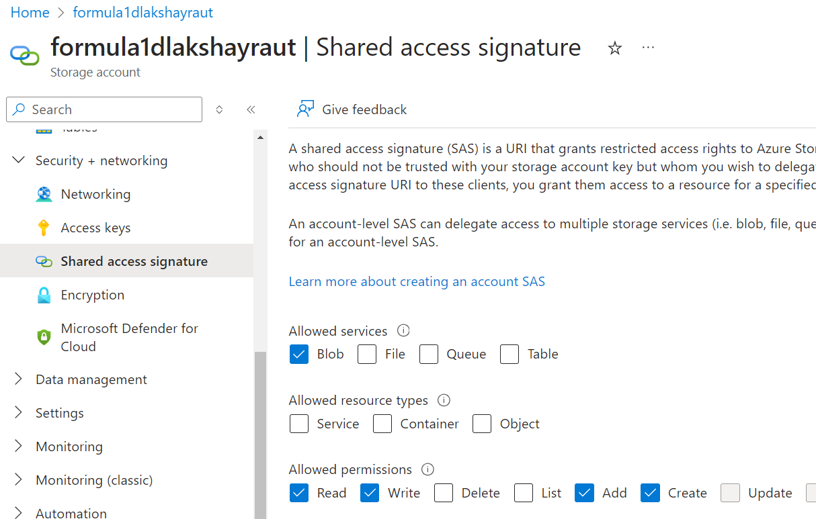

Allowed resource types:

Ensure that “Container” and “Object” are selected for blob service.

Screenshot #2

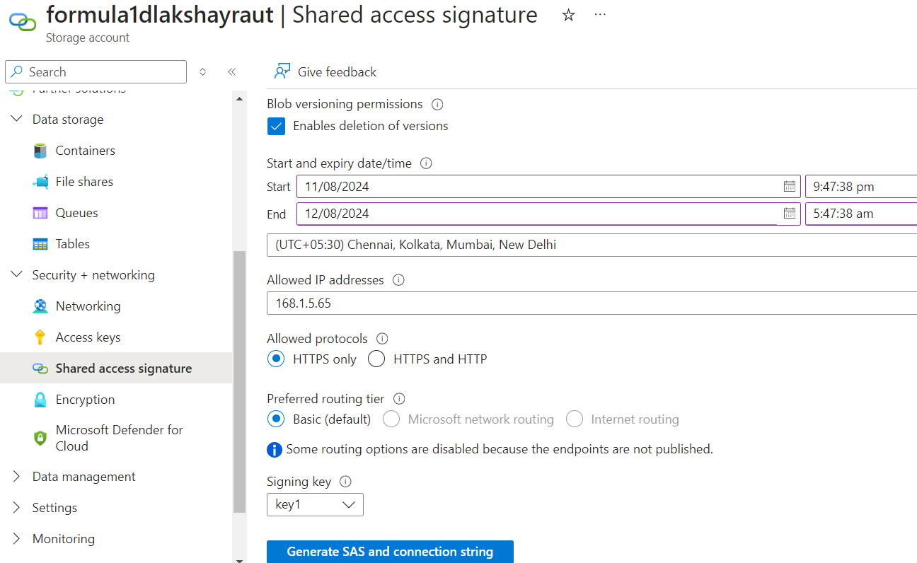

##### Generated keys would look like this below the Generate SAS and connection string button:

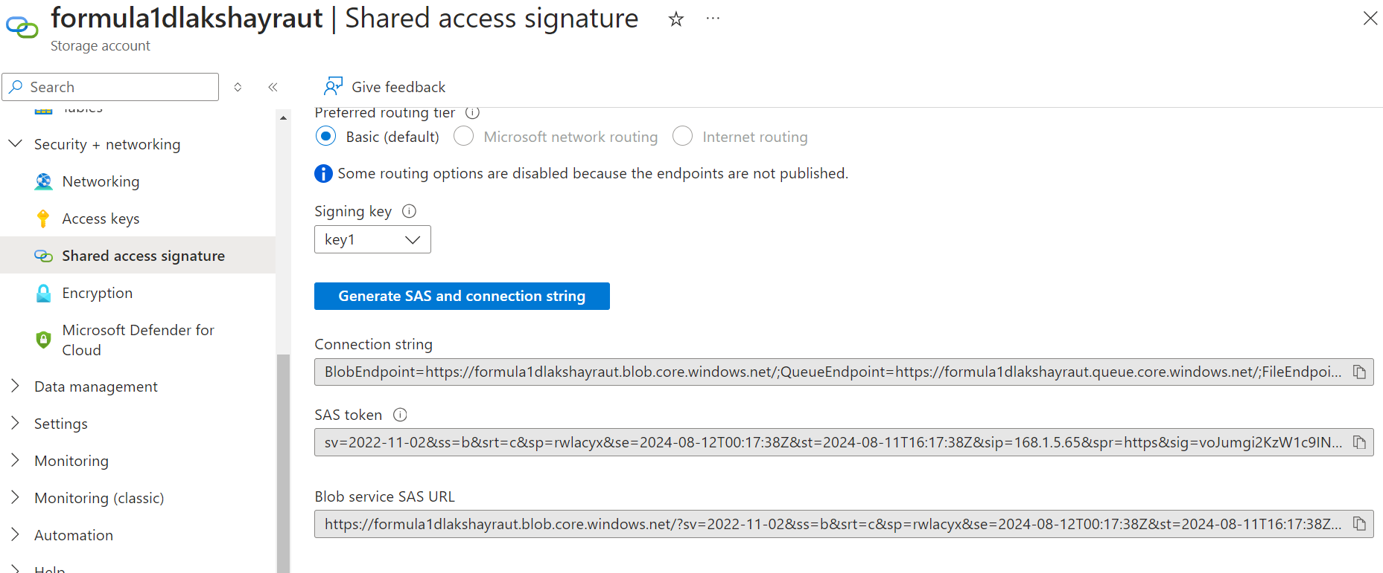

#### Method #2 – using options over the container.

Go to storage account -> containers.

Click on the three dot button of your container.

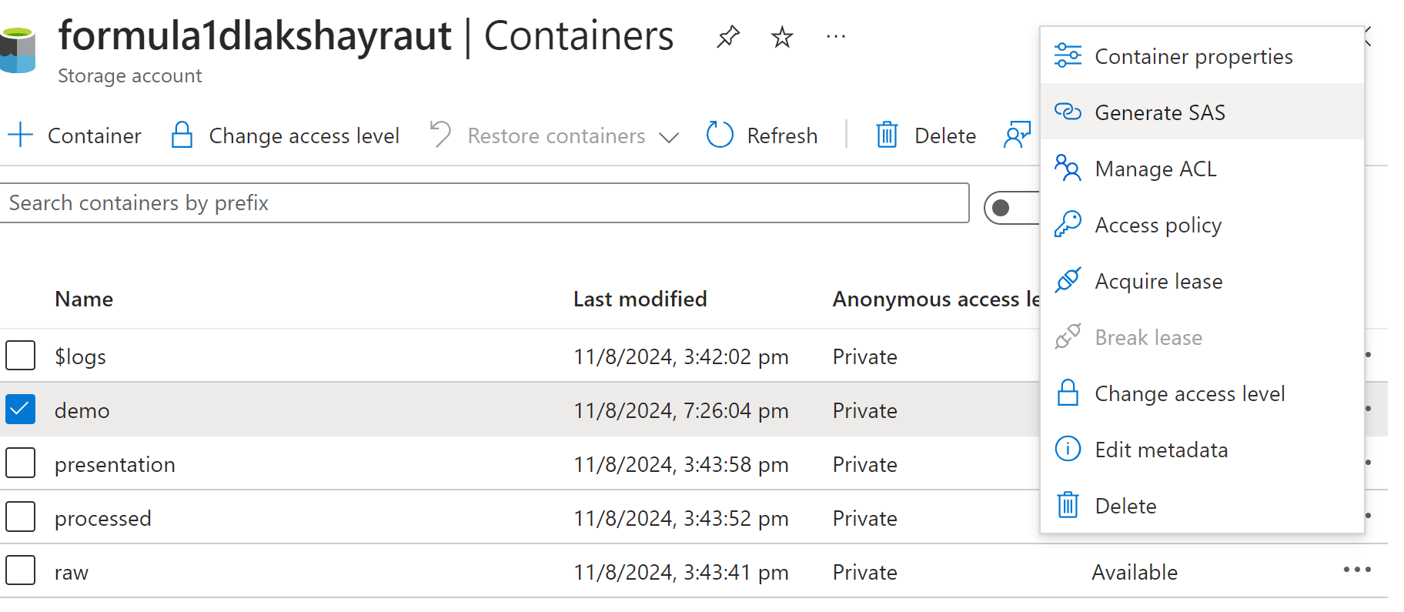

Now click on Generate SAS and a slider will open up.

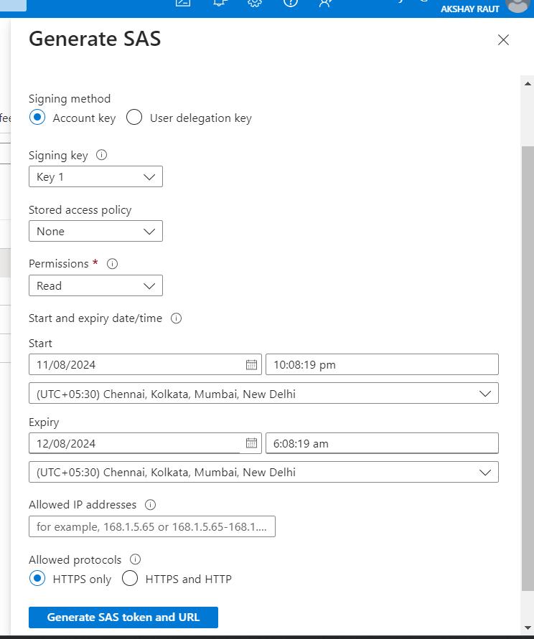

The “Permissions” dropdown is multi-select.

Note – When you regenerate the SAS token, the previously generated one becomes invalid.

### Hands-on – Connect to ADLS storage account using SAS token.

We can refer this link to copy the sample command for Spark SAS configuration.

<https://learn.microsoft.com/en-us/azure/databricks/connect/storage/azure-storage#sastokens>

This link gives an example of getting the SAS token value via Secret Scopes in Databricks which fetches the token value from Azure Key Vault.

We can simplify that into directly passing the token value like this:

spark.conf.set("fs.azure.account.auth.type.formula1dlakshayraut.dfs.core.windows.net", "SAS")

spark.conf.set("fs.azure.sas.token.provider.type.formula1dlakshayraut.dfs.core.windows.net", "org.apache.hadoop.fs.azurebfs.sas.FixedSASTokenProvider")

spark.conf.set("fs.azure.sas.fixed.token.formula1dlakshayraut.dfs.core.windows.net", "sv=2022-11-02&ss=b&srt=c&sp=rwlacyx&se=2024-08-12T00:17:38Z&st=2024-08-11T16:17:38Z&sip=168.1.5.65&spr=https&sig=voJumgi2KzW1c9INCSz9%2Bqt7A9JTr0ivAPMDzAcR%2BME%3D")

## Access Azure Data Lake Gen2 from Databricks using Service Principal

Service Principals are quite similar to user accounts.

They can be registered in Azure Active Directory and assigned permissions required to access certain resources using RBAC in the subscription.

Service Principals are recommended method to be used in automated tools such as Databricks jobs and CI/CD pipelines. This is because they provide better security and traceability.

In a good architecture, each application will have its own Service Principal with limited required permissions.

Steps:

1. Register an Azure AD app as service principal. Each app gets a unique app id or client id.
2. We also need to create a secret for this service principal.
3. Then we need to configure Databricks to access the ADLS via service principal’s app Id, directory id (tenant ID), and secret.
4. And finally we need to assign a role “Storage Blob Data Contributor” to the Data Lake.

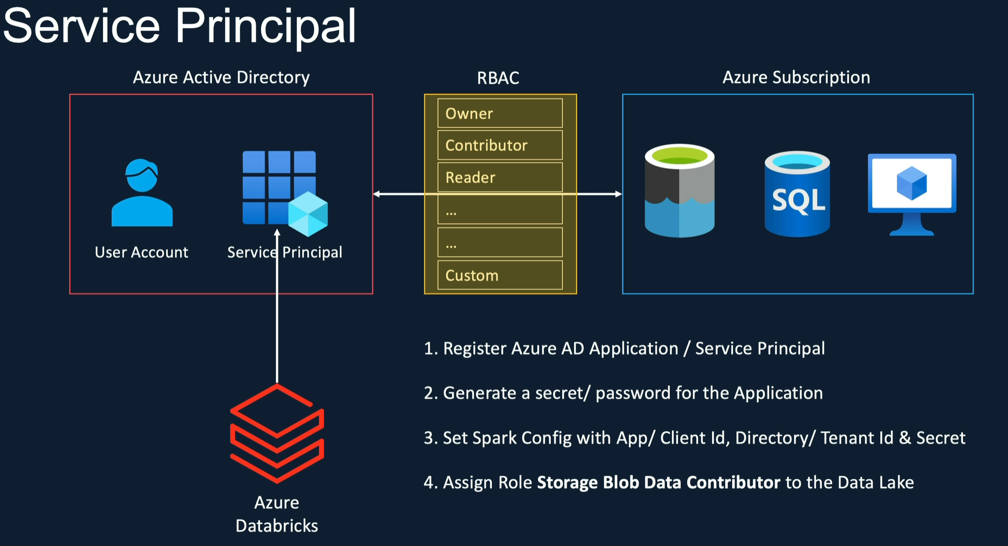

### Hands-on – Create Azure AD app or service principal.

In Azure portal, either search for Azure Active Directory and then go to App registrations or search for “App registrations”.

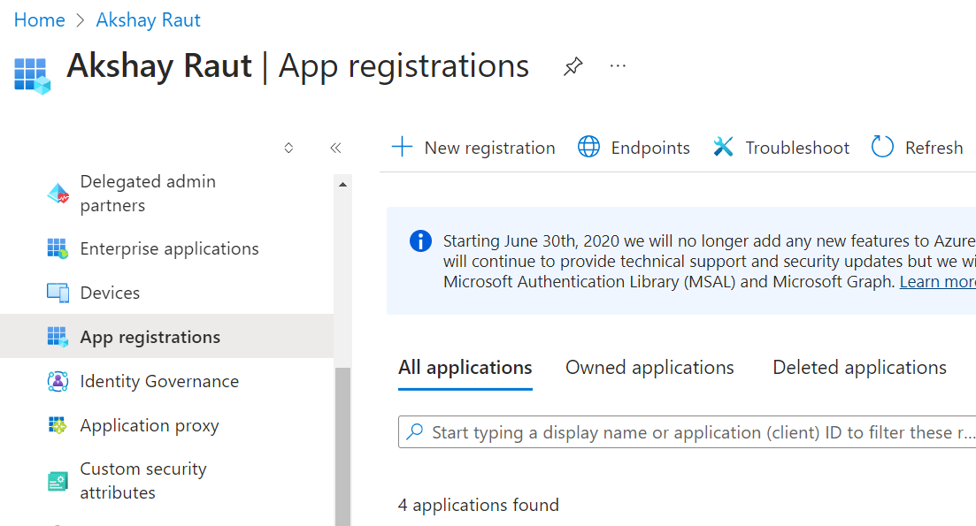

Click on New Registration.

On the “Register an application” page, fill in the details.

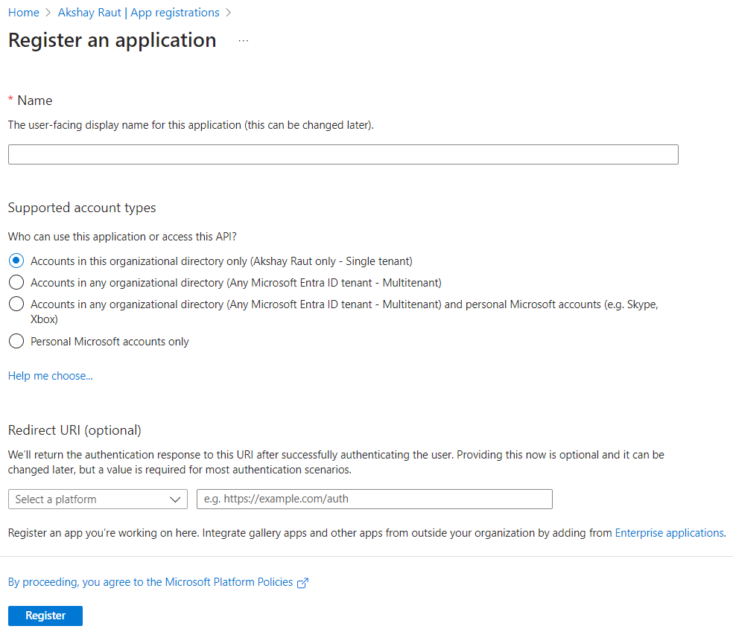

The newly created app will look like this:

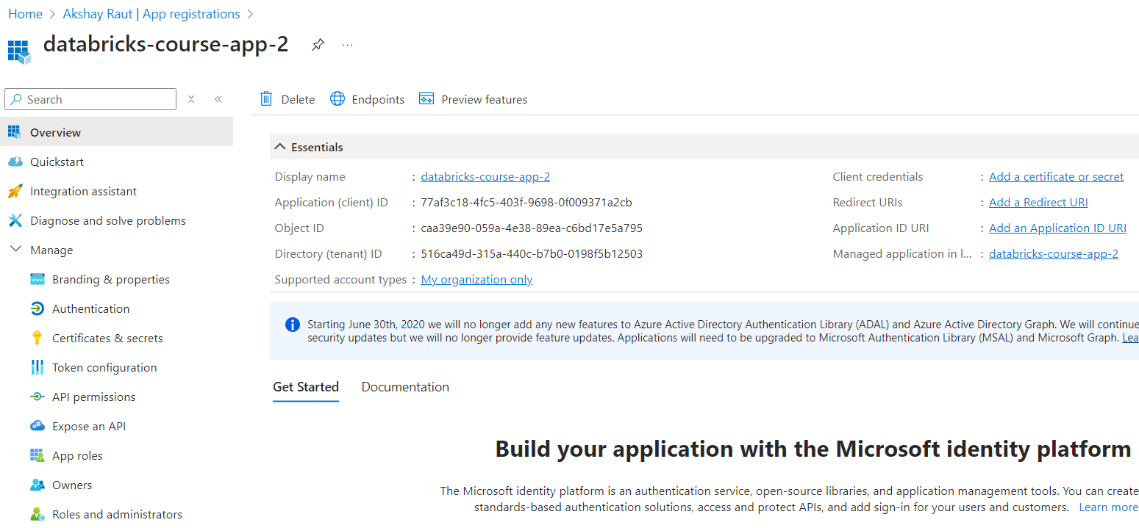

From here, take note of the Application (client) ID and Directory (tenant) ID.

### Hands-on – Create client secret of the app.

In your service principal or Azure AD app, go to “Certificates & secrets”.

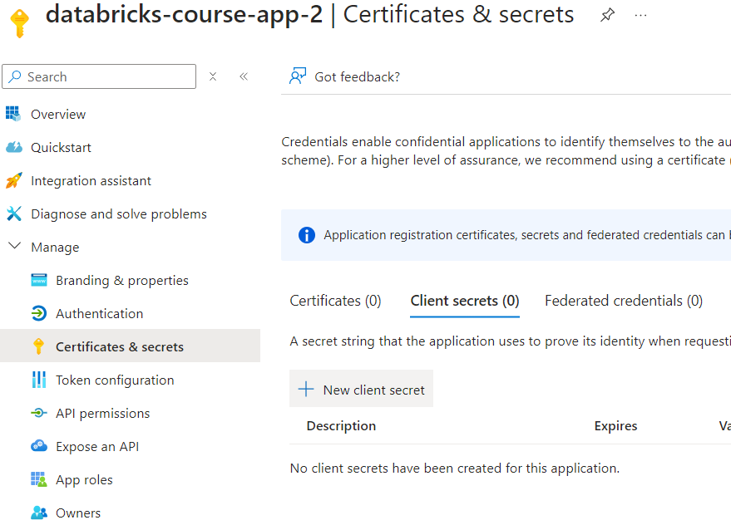

Click on “Client secrets” and “+ New client secret”.

Fill in the description and expiry of the secret in the slider and click “Add”.

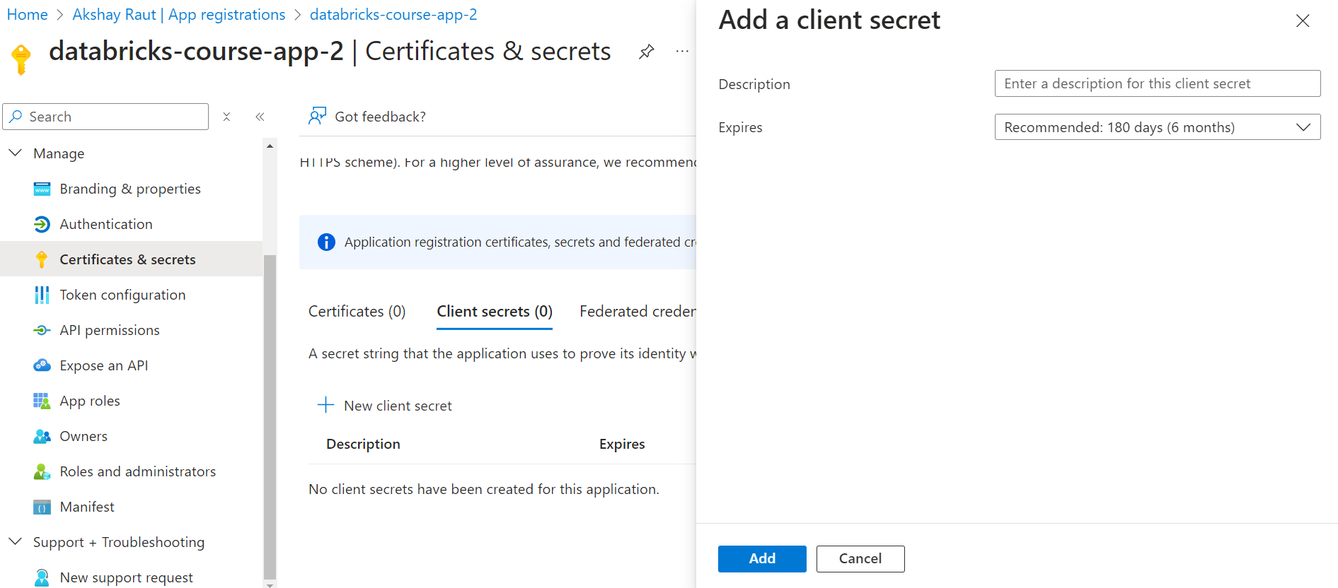

Generated secret would look like this:

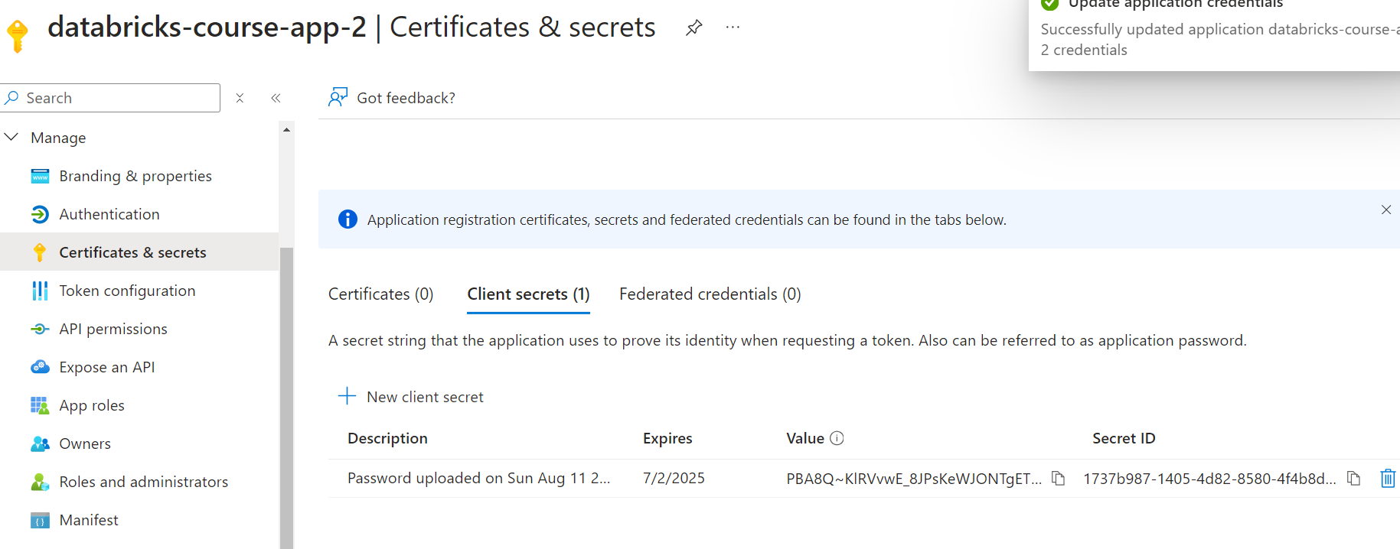

Take note of the Value as Client Secret to be used in Databricks notebook.

Note – once you navigate away from this page, you won’t be able to see the Value again.

### Hands-on – Using service principal to connect to ADLS.

Refer to see steps for configuring Spark with Service Principal: <https://learn.microsoft.com/en-us/azure/databricks/connect/storage/azure-storage#azureserviceprincipal>

Just like previous hands-on, let’s ignore the secret-scope related lines of codes.

Our sample command is:

|  |
| --- |
| spark.conf.set("fs.azure.account.auth.type.<storage-account>.dfs.core.windows.net", "OAuth")  spark.conf.set("fs.azure.account.oauth.provider.type.<storage-account>.dfs.core.windows.net", "org.apache.hadoop.fs.azurebfs.oauth2.ClientCredsTokenProvider")  spark.conf.set("fs.azure.account.oauth2.client.id.<storage-account>.dfs.core.windows.net", "<application-id>")  spark.conf.set("fs.azure.account.oauth2.client.secret.<storage-account>.dfs.core.windows.net", service_credential)  spark.conf.set("fs.azure.account.oauth2.client.endpoint.<storage-account>.dfs.core.windows.net", "https://login.microsoftonline.com/<directory-id>/oauth2/token")  ​ |

After replacing the placeholders our relevant parameters, it would look like this:

Final configuration command:

|  |
| --- |
| spark.conf.set("fs.azure.account.auth.type.formula1dlakshayraut.dfs.core.windows.net", "OAuth")  spark.conf.set("fs.azure.account.oauth.provider.type.formula1dlakshayraut.dfs.core.windows.net", "org.apache.hadoop.fs.azurebfs.oauth2.ClientCredsTokenProvider")  spark.conf.set("fs.azure.account.oauth2.client.id.formula1dlakshayraut.dfs.core.windows.net", client_id)  spark.conf.set("fs.azure.account.oauth2.client.secret.formula1dlakshayraut.dfs.core.windows.net", client_secret)  spark.conf.set("fs.azure.account.oauth2.client.endpoint.formula1dlakshayraut.dfs.core.windows.net", f"https://login.microsoftonline.com/{tenant_id}/oauth2/token")  ​ |

### Hands-on – Assign role ‘Storage Blob Data Contributor’ to Data Lake for our service principal.

Navigate to the Data Lake resource and open up “Access Control (IAM)”.

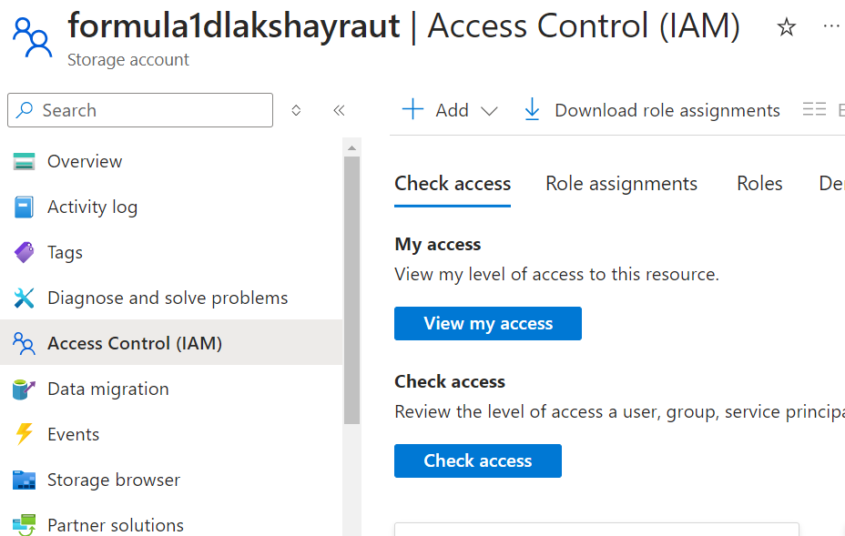

Click on Add -> Add role assignments.

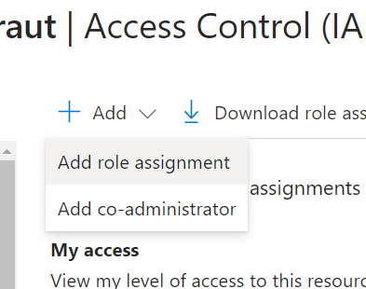

On the next page, search for ‘Storage Blob Data Contributor’ and click Next.

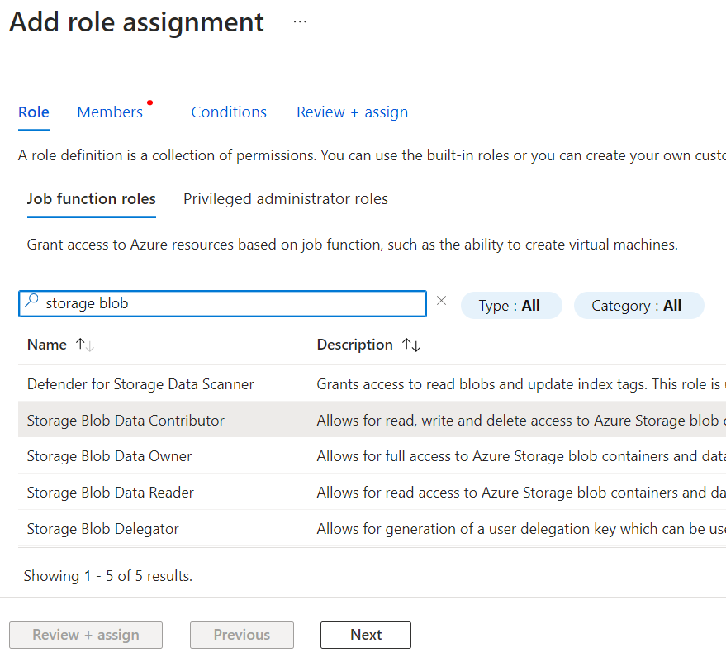

In the next page, ensure that “User, group, or service principal” is selected and then click on “+ Select members”.

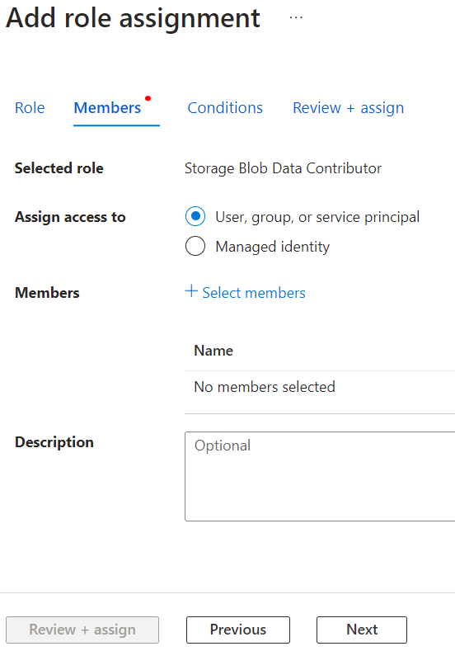

A slider will open up. Search for your service principal name, select it and click Select at bottom. 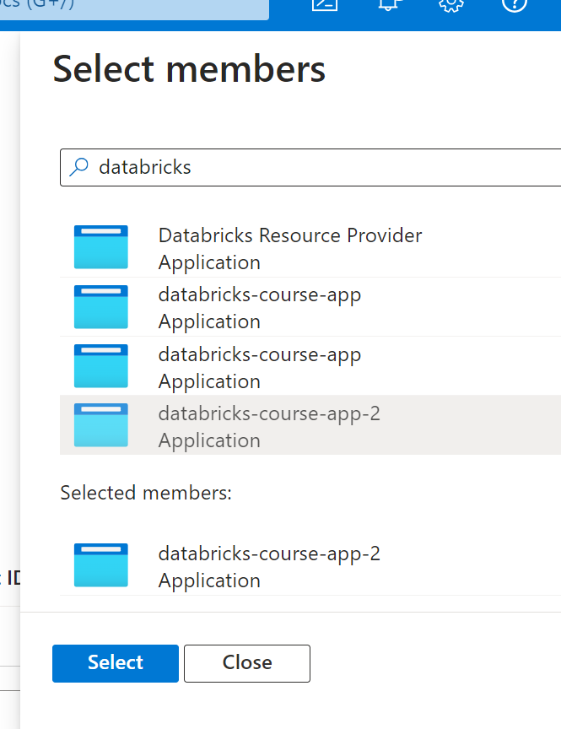

Click on Review + assign.

You can see the service principal has been assigned Contributor access of the storage account in the “Role assignments” tab.

Now if you run your notebook commands, it can access the ADLS and read contents of the file.

## Cluster Scoped Authentication

We have seen Session scoped authentication.

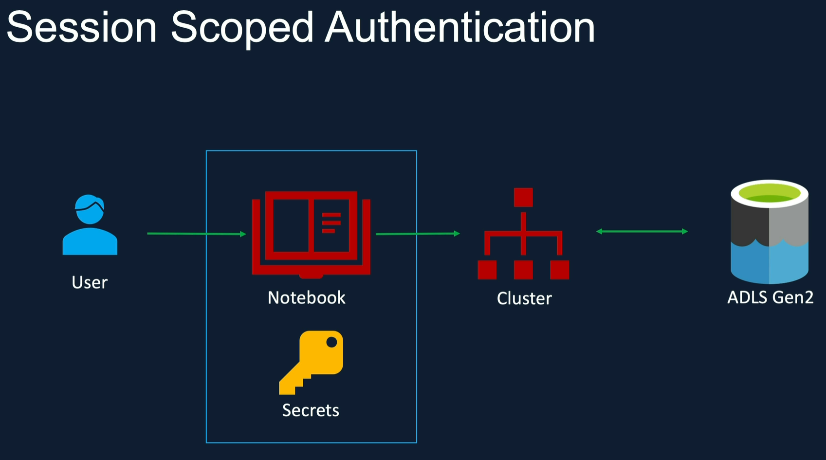

But if want multiple notebooks connected to a cluster to access same set of keys to connect to ADLS, then we can cluster level configuration.

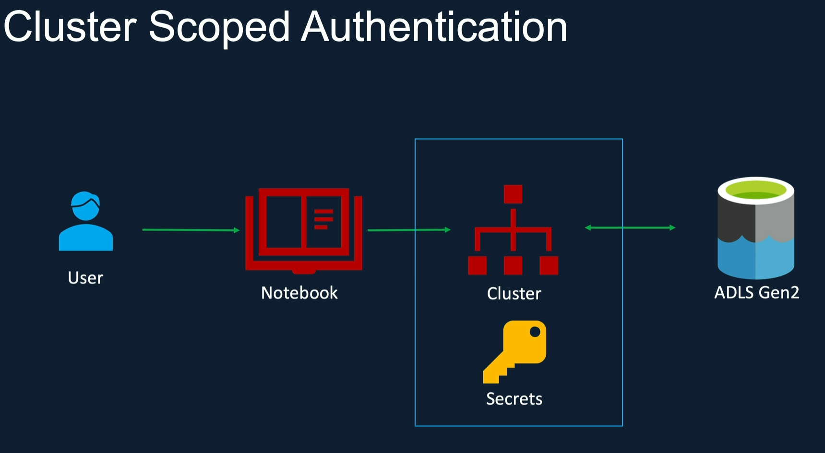

You might be wondering, instead of authenticating from notebooks, can we do that within the cluster at the startup, so that every notebook connecting to the cluster has access to the storage.

This is what is referred to as Cluster Scoped Authentication.

We can do that by specifying the Spark configuration parameters and the corresponding secret values within the Cluster configuration. So when the Cluster is created, it already has the Spark configuration set with the right secret values.

During the Cluster creation, the authentication with the Data Lake will be complete, i.e. Spark configurations are executed.

One drawback with this approach, is that every notebook which runs on this cluster will have the access to the Data Lake. So this cluster could not be used for other purposes, where some of the users should have limited access to the data or no access to this data at all.

Effectively, by defining the credentials in the cluster, we are making the cluster specific for one permission group, in which all users require the same level of access. This may not be what you want in a large project.

For example, if the Data Engineers want permissions to certain storage accounts, but the Analysts should not have, you need to create two clusters for the specific purposes and they cannot share one cluster. Because of this, it's not a widely used approach in the industry from my experience.

### Hands-on – Create cluster level credentials in Azure Databricks.

On Azure Databricks workspace, either create a new cluster or edit an existing cluster.

Look for the Advanced options section.

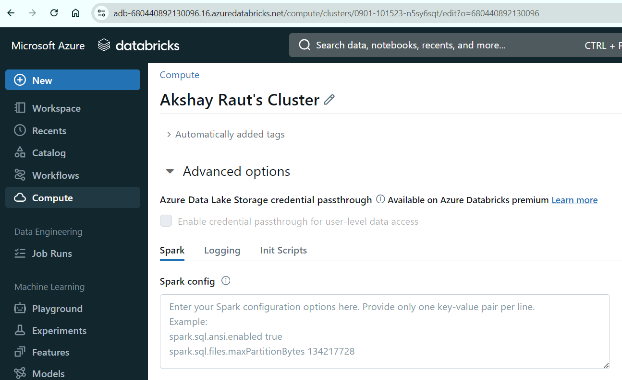

You will find some a textbox for Spark config. This sets a space separated name-value pair of configurations.

We can store any type of configuration we have seen so far.

For this hands-on practice, I will store Storage Account key.

Copy paste the ADLS endpoint with storage key in this manner.

<ADLS endpoint> <storage account key>

|  |
| --- |
| fs.azure.account.key.formula1dlakshayraut.dfs.core.windows.net yvtHukWOK9l+r4EXo++29hRlRSObC59X3Yf+1k18uDb3PUVh0zpQijZLwIktO/3gXehnEA77dt4x+AStLYRx2A== |

You will get a warning not to reveal secrets and keys in the open.

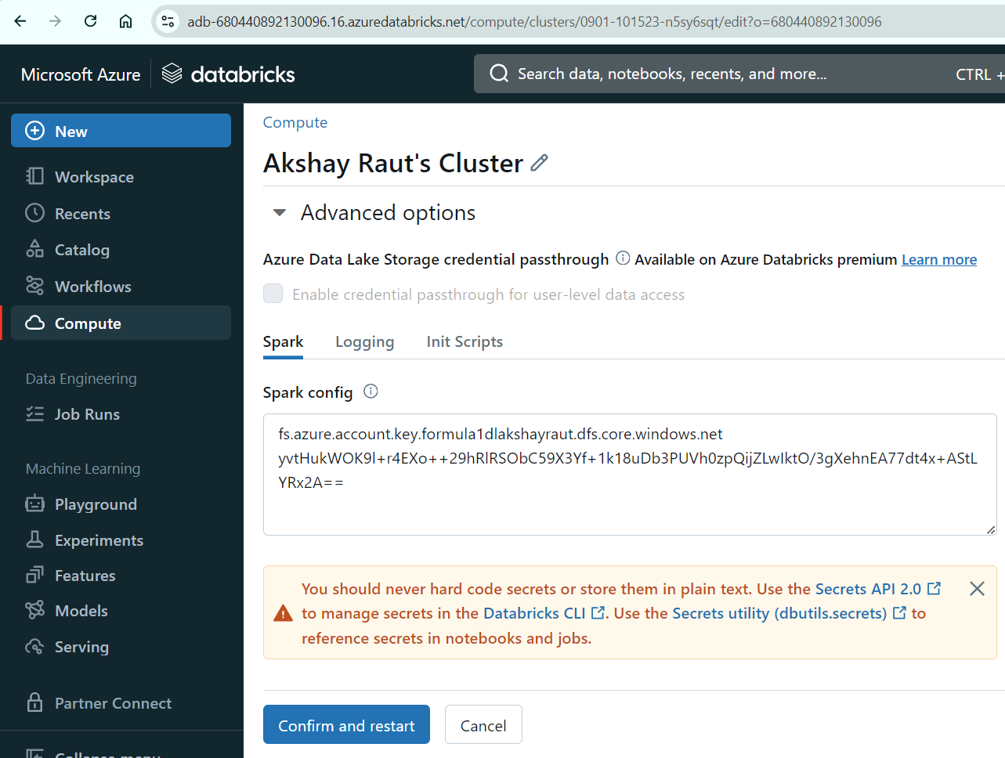

Note: When you change anything in cluster configuration, the cluster will restart so avoid making such changes during productive hours.

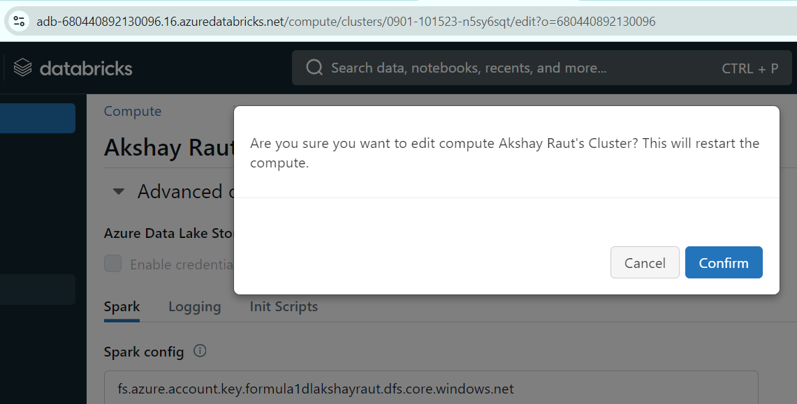

After successfully restarting the cluster, you should remove any spark config commands that was supposed to store ADLS keys or SAS or whatever you were using.

Now you can run the notebook and it should work just like it did with notebook level spark configurations.

Output: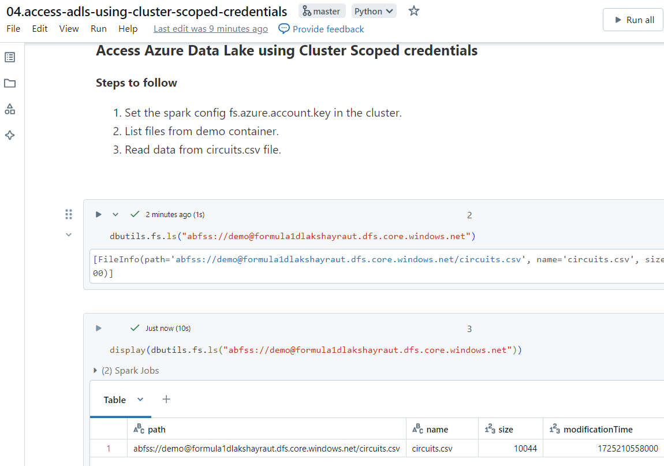

Note: Make sure that you remove the configurations from cluster if you are going to try other methods of connecting to ADLS.

## AAD Credential Passthrough

If you need to control access to ADLS via Azure Active Directory inside Databricks then use AAD Credential Passthrough.

This option is only available to Premium Databricks workspaces.

Databricks passes logged in user’s credentials from AAD to ADLS and if the logged in user has access to ADLS so will the notebook.

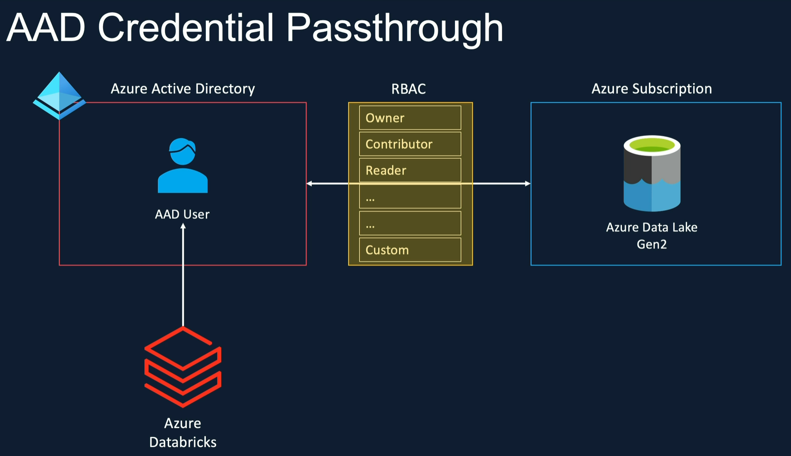

Hands-on – Enable Credential Passthrough to connect to ADLS.

Go to your Databricks cluster’s edit mode, and its Advanced options.

You will find a checkbox labeled “Enable credential passthrough for user level data access”.

If it’s disabled then it means your Databricks workspace is not on premium tier.

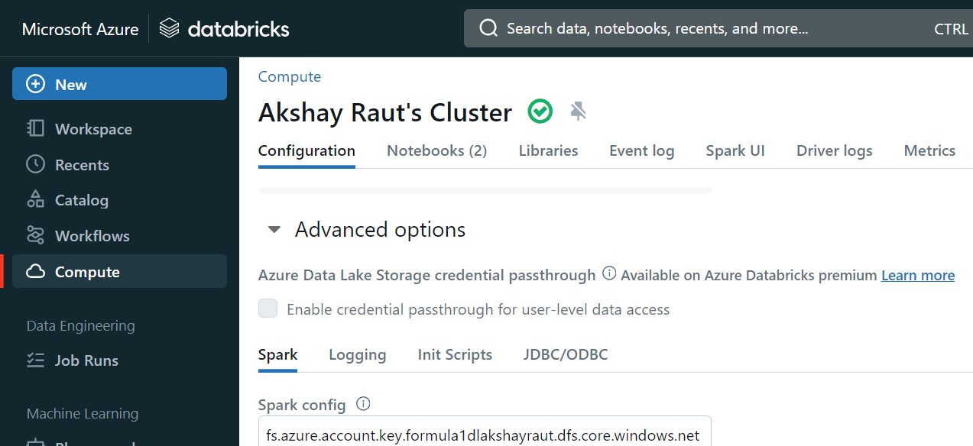

Now enable that setting.

I suggest you either make a clone of the previous notebook that did not have any spark configuration or run the same notebook because that’s best suited for this example.

When you run that notebook, you will encounter an error.

Error:

|  |
| --- |
| ExecutionError: An error occurred while calling o390.ls.  : Operation failed: "This request is not authorized to perform this operation using this permission.", 403, GET, https://formula1dlakshayraut.dfs.core.windows.net/demo?upn=false&resource=filesystem&maxResults=5000&timeout=90&recursive=false, AuthorizationPermissionMismatch, "This request is not authorized to perform this operation using this permission. RequestId:ca8b4857-001f-001d-2295-fc2781000000 Time:2024-09-01T17:39:59.0854380Z" |

Screenshot:  
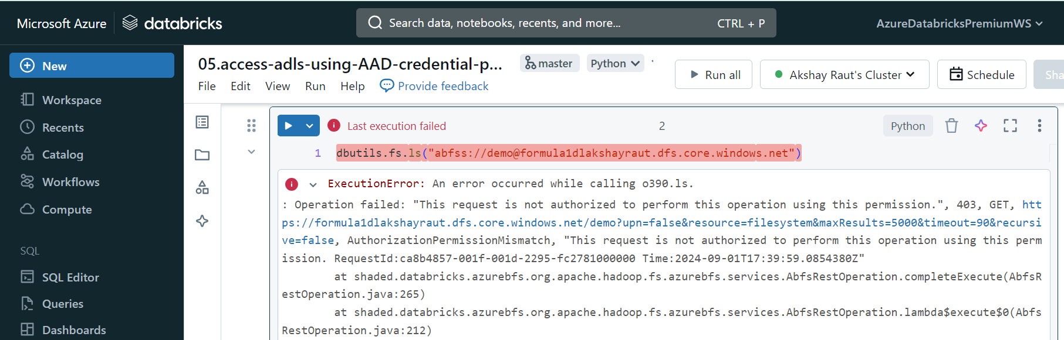

This is because even though I am the owner of Azure Data Lake storage account but I have not assigned my account as Owner in the Access Control (IAM).

Browse to your storage account, give yourself Owner permission and come back to the notebook to re-run it.

Wait for couple of minutes before you re-run the notebook.

Output:  
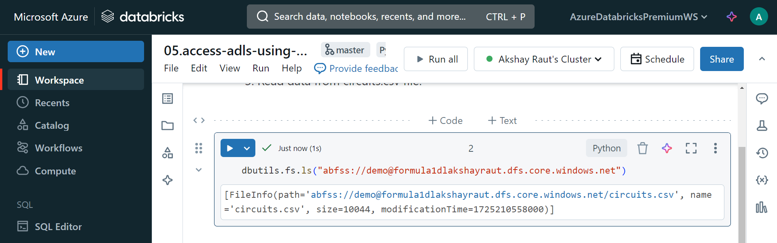

Note: When you are done with the exercise, uncheck the Credential Passthrough for your cluster.

Note: Delete the Premium Databricks workspace to avoid high cost.

## What is the recommended access pattern to connect to Data lake from Azure Databricks?

We have seen these access patterns.

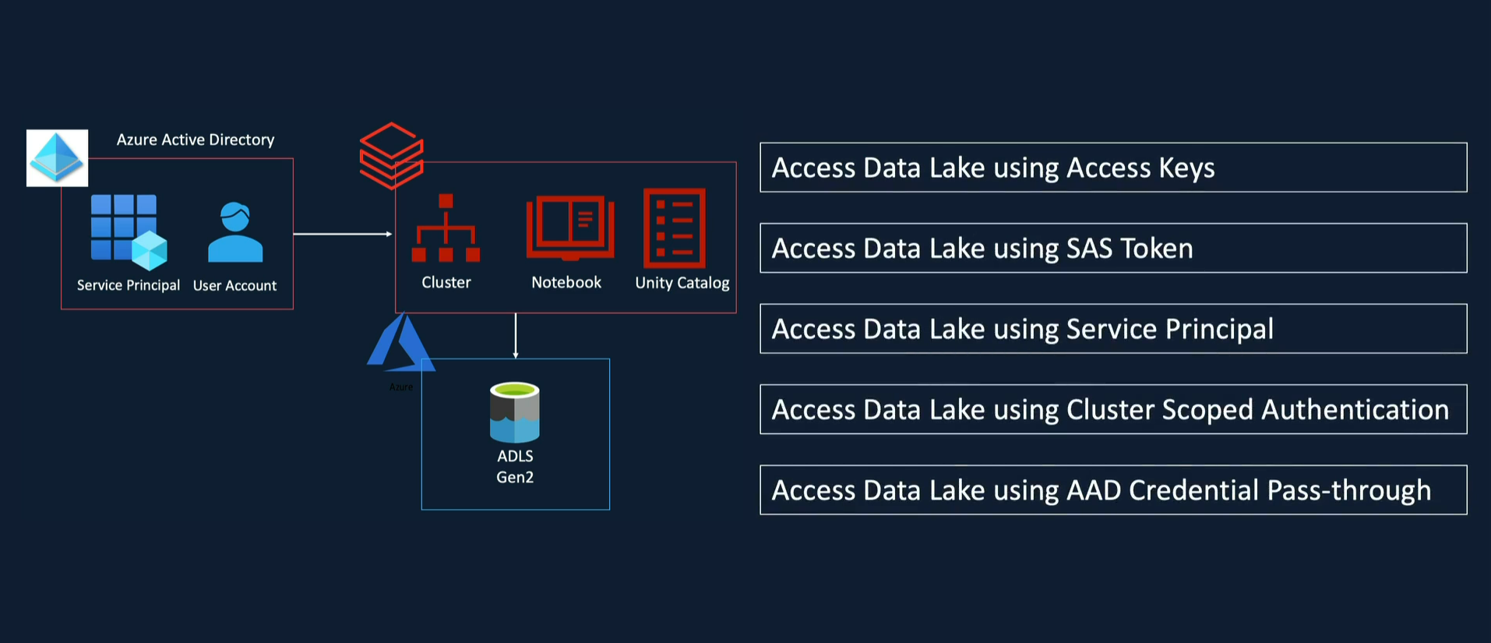

Recommended:

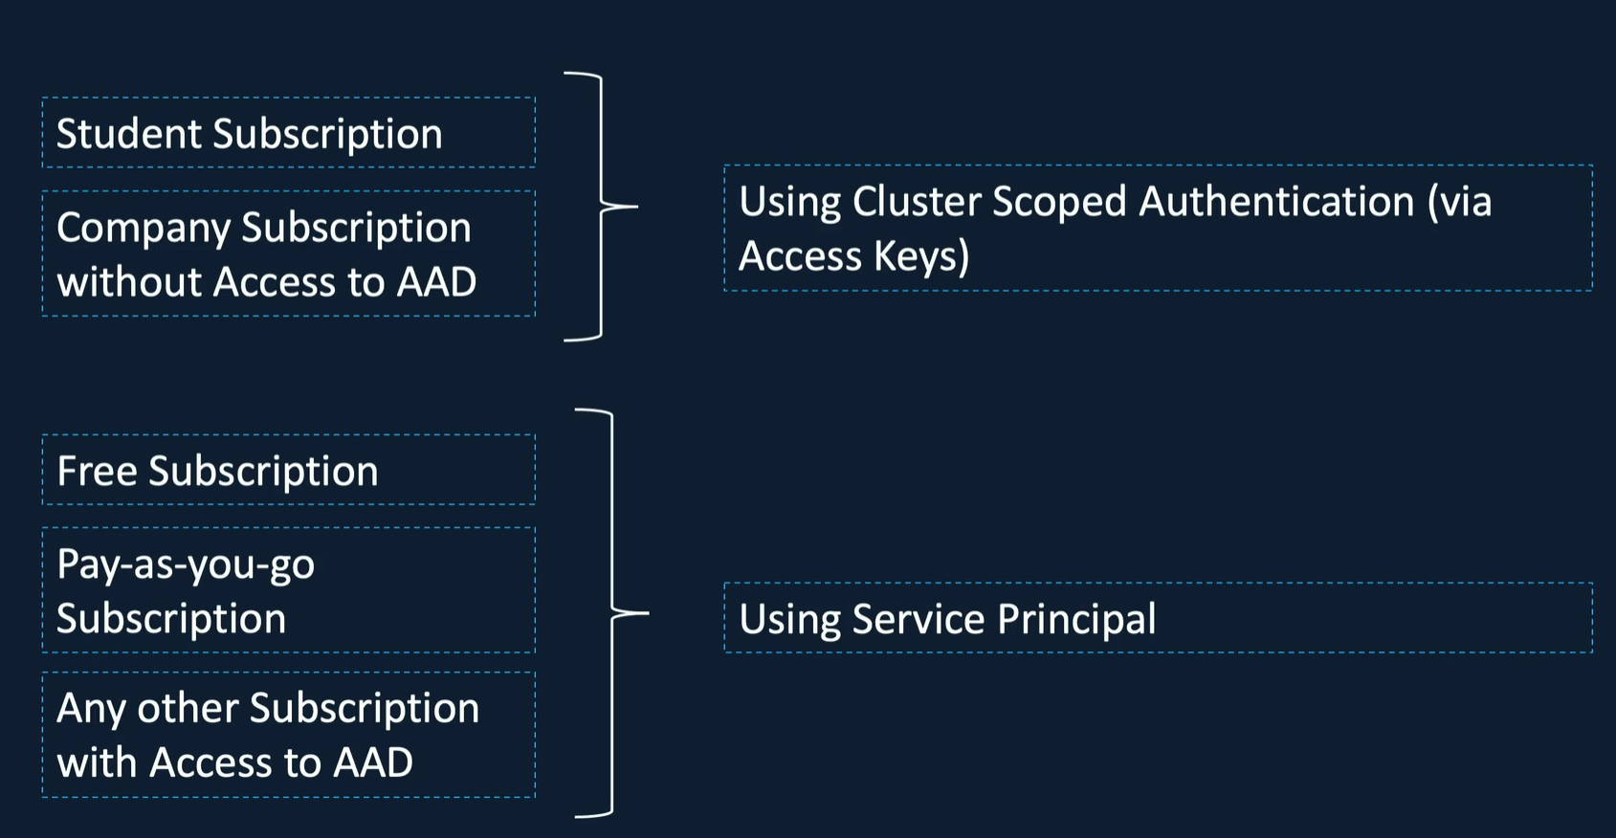

# Using SQL in Spark Applications

# Spark SQL – Databases / Tables/ Views

Our data is stored in Azure Data Lake as files of varying types such as CSV, JSON, or Parquet.

In order for Spark to treat this data as tables and columns, we need to register this data in a meta store.

Meta store is a storage for storing metadata about the data files.

E.g. Location of the file, format of the data, column names, etc.

Spark uses a meta store provided by Apache Hive project which is called Hive meta store.

Hive meta store is most commonly used meta store in Data Lake space.

When it comes to choosing the storage for hive meta store, we have a choice.

We can either choose the Default Databricks managed Meta Store or the External Storage option of your own.

So you've got a choice between Azure SQL, MySQL, MariaDB and a few others.

Once we've registered our tables in the hive meta store, we can then use Spark SQL to access these tables like we would in a relational database.

Just to summarize, the data is usually stored in an object storage which is ADLs in our case.

Hive Meta Store keeps the information about the file, such as the location, name of the file, table, column, etc.

When you run a Spark SQL command, Spark uses the meta store to apply the schema and access the files accordingly, as if we are accessing any relational table.

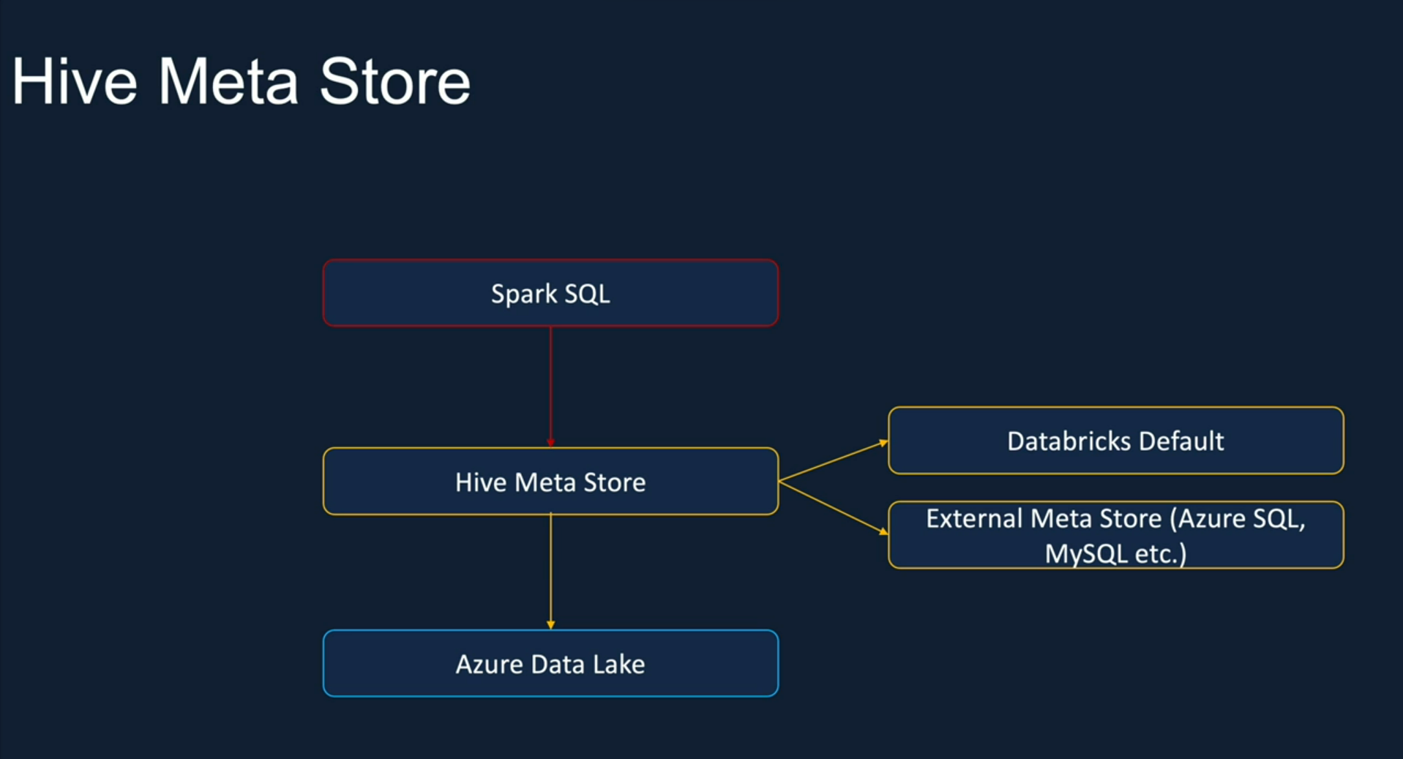

How Databricks organizes databases, tables, and views.

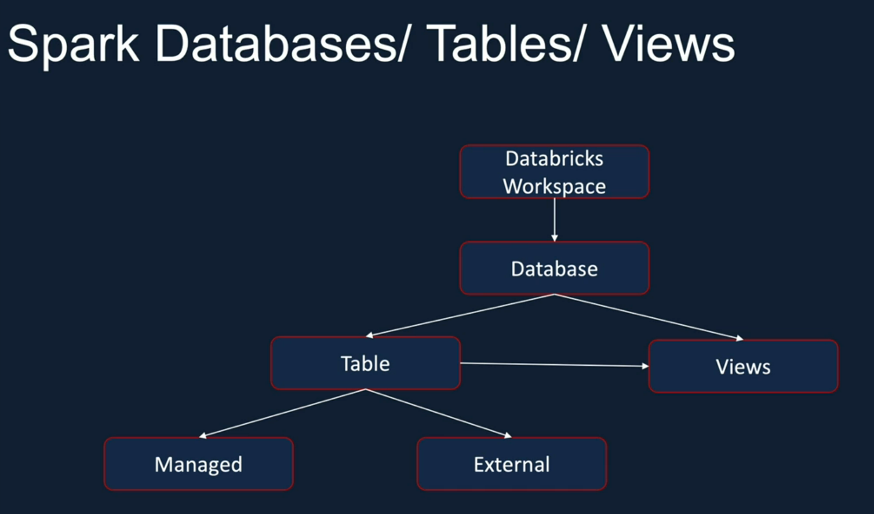

## Databases

At Databricks Workspace can have a number of databases. They are also referred as schemas.

Within a database, they can have a number of tables and views.

## Tables

Tables are basically structures given to the data stored in an object storage.

As we said, ADLs is our object storage.

There are two types of tables in Spark.

The first one is called the Managed Table and the other one is called External or Unmanaged.

In the case of Managed Table, Spark maintains both the metadata and data files in Hive Meta Store, associated with the table, which is stored in ADLs in our case.

In the case of External Tables, Spark only manages the metadata and we manage the data files.

What I mean by that is, for External Tables we specify the location of the data files and Spark doesn't decide it for itself.

Also, the main properties that dropping the table for an External Table doesn't delete the files, whereas in the case of Managed Table, it deletes the files as well as drop the table.

## Views

Views can be built on the tables with a selection of data.

For example, you could apply a filter to a table, or you could select just a certain number of columns and then create a view with that information.

## Database operations

### How to create Databases?

You can use this command to create a new database.

CREATE DATABASE demo.

It will create demo.

### But what if the database exists?

Then we will get error saying:

“Error in SQL statement: AnalysisException: org.apache.hadoop.hive.metastore.api.AlreadyExistsException: Database demo already exists”.

If we are going to use this type of statements in multiple notebooks then we can add a check IF EXISTS.

CREATE DATABASE IF EXISTS demo

### Where to find existing databases?

Start up a cluster and once it’s started then click on Catalog on left menu.

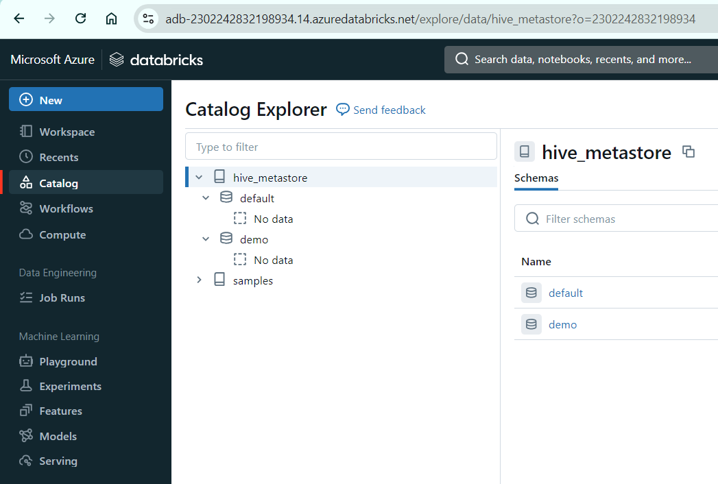

### How to show list of all databases?

Display databases using command:

SHOW DATABASES;

### Get details of a database.

DESCRIBE DATABASE demo;

It will give database name, comment, its location, and its owner.

Output:

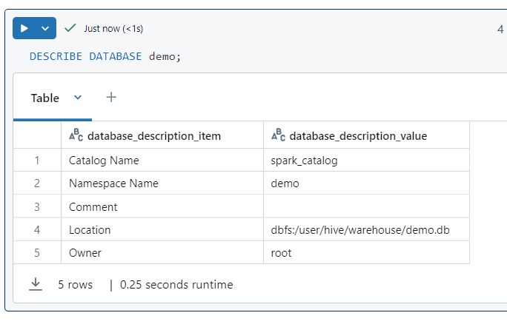

If you apply options such as EXTENDED to this command then you get properties details.

DESCRIBE DATABASE EXTENDED default;

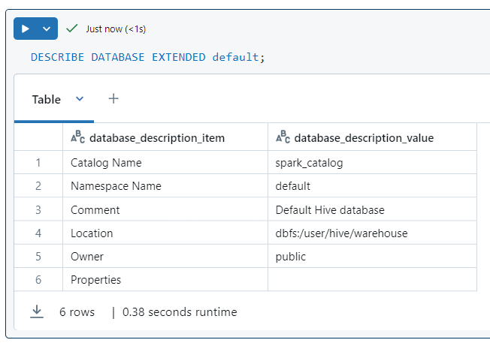

This is useful if you have passed some properties to the CREATE DATABASE command during creation.

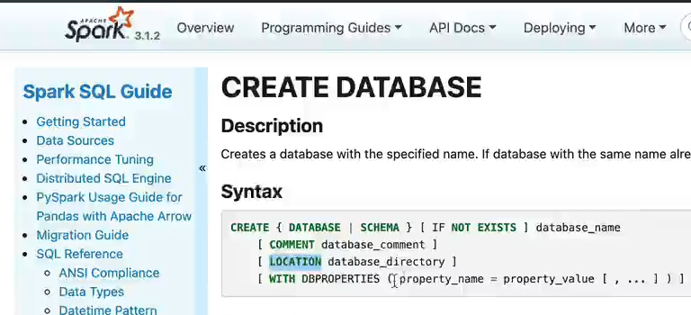

### How to check the current database?

SELECT CURRENT_DATABASE()

Output:

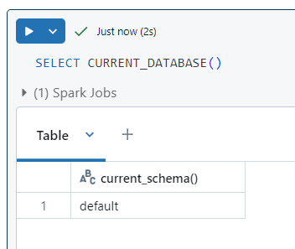

### How to show all tables of current database?

SHOW TABLES;

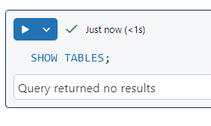

### How to show all tables of any database?

SHOW TABLES in demo;

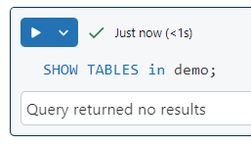

### How to change current database?

USE demo;

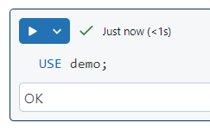

## Managed Tables